

**DESIGN AND IMPLEMENTATION OF A MEDICAL BOOKING SYSTEM.**

**BY**

**AKIOYE, OLUWATOBI STEPHEN**

**17CG023145**

**A RESEARCH PROJECT SUBMITTED TO THE DEPARTMENT OF COMPUTER INFORMATION SYSTEM, COLLEGE OF SCIENCE AND TECHNOLOGY, COVENANT UNIVERSITY, OTA IN PARTIAL FULFILLMENT OF THE REQUIREMENTS OF THE AWARD OF A BACHELOR OF ENGINEERING (B.Eng.) HONOURS DEGREE IN COMPUTER SCIENCE**

**JUNE, 2021**

# DEDICATION

I dedicate this project to the Almighty God who has kept me through my entire stay in Covenant University and has provided me with the required knowledge, wisdom and understanding used in making this research project a success.

# CERTIFICATION

This is to certify that ETU, EGBE-ETU EMMANUEL, a student of the Department of Civil Engineering with matriculation number 11CI012258, has successfully completed the requirements of this research project. The work composed in this project is original and has not, to the best of my knowledge, been submitted in part or full for any other diploma or degree of this or any other university.

Etu, Egbe-Etu Emmanuel ……………….. ……………….

Author Signature Date

Engr. Tenebe Theophilus ...……………… ...……………..

Project Supervisor Signature Date

Dr. Olukanni David ...……………….. .……………….

Head of Department Signature Date

# DECLARATION

I hereby declare that I am the sole author of this research work and that it has not been presented by previous application for a Bachelor of Engineering degree. This project is based on my original study and the views of other researchers have been duly expressed and acknowledged.

………………………………………… Etu, Egbe-Etu Emmanuel

June, 2016.

# ACKNOWLEDGEMENT

I humbly wish to acknowledge Mr. Taiwo, Olugbenga S. from the Department of Biological Sciences, Covenant University who was very instrumental to the success of this project, I am extremely grateful for your assistance. To Mr. Gift Olimaro; Mrs. Obafemi, Yemisi; Dr. Ejoh, Samuel; and Mrs. Owotoye A.O., I cannot thank you enough for your kindness and assistance; may God reward you richly.

To my project supervisor Engr. Tenebe Theophilus I say a big thank you for your guidance, patience and love through the project, I say a big thank you; the principles of hard work and honesty will not be forgotten. I cannot ignore the input of my lecturers; Engr. PraiseGod Emenike, Dr. Ben Ngene and the entire Department of Civil Engineering as a whole for their invaluable contributions during my stay in Covenant University.

Words cannot convey my gratitude to my parents; Arc. & Mrs. Emmanuel Etu, my siblings; Prince, Kindness, Ken, Sam and all my aunts and uncles whose support made this project possible, I love you dearly and to my friends: Emakhu, Olamijulo, Oluwatoba, Ojokutu, Ogundare, and Fagbohun who contributed in different capacities I am extremely grateful.

Finally to God Almighty who has always been my help and protection I say the biggest thank you of all.

# TABLE OF CONTENTS

DEDICATION ii

CERTIFICATION iii

DECLARATION iv

ACKNOWLEDGEMENT v

LIST OF FIGURES ix

LIST OF TABLES x

LIST OF PLATES xii

ABSTRACT xiv

CHAPTER 1 1

* 1. INTRODUCTION 1
  2. Statement of Problem 2
  3. Aim 2
  4. Objectives 2
  5. Justification of study 2
  6. Scope of the study 3

CHAPTER 2 4

* 1. LITERATURE REVIEW 4
  2. Introduction 4
  3. Sewage 4
     1. Categories of Sewage 5
     2. Sources of Sewage 5
  4. Sewage Degradation 6
  5. Aeration 6
     1. Methods of Aeration 7
     2. Types of Aeration 9
  6. Wastewater 10
     1. Constituents of wastewater 11
     2. Types of wastewater 11
  7. Wastewater Treatment 11
     1. General Considerations for the Treatment of Wastewater 16
     2. Parameters for measuring wastewater 16
  8. Disinfection 19
     1. Disinfection Techniques 20
     2. Effects of Disinfectants on Bacterial growth 23
     3. Factors influencing the effects of disinfectant on bacterial growth 24
  9. Camphor 24
     1. Physical Properties of Camphor 26
     2. Other Characteristics of Camphor 27
     3. Uses of Camphor 27
     4. Production of Camphor 27
     5. Reactions 27
     6. Effects of the various constituents of Camphor on bacteria life 28
  10. Septic Tank 30
      1. Physical Processes 30
      2. Biological and Chemical processes 32
      3. Treatment achieved with domestic sewage 32
      4. Factors affecting septic tank performance 32

CHAPTER 3 33

* 1. METHODOLOGY 33
  2. Introduction 33
  3. Sample Collection and Preservation 33
  4. Methods for Analysis 33
     1. Hanna Instrument Edge Multi-meter 34
     2. Standard Test Procedures 39

CHAPTER 4 48

* 1. RESULTS AND DISCUSSION 48
  2. Introduction 48
  3. Results and Discussion 48

CHAPTER 5 68

* 1. CONCLUSION AND RECOMMENDATIONS 68
  2. Conclusion 68
  3. Recommendations 68

References 70

# LIST OF FIGURES

**Fig 2.1:** Typical wastewater treatment facility 13

**Fig 2.2:** Wastewater treatment plant overview… 14

**Fig 2.3:** Municipal sewer facility 15

**Fig 2.4:** Growth rate of micro-organisms as a function of pH… 18

**Fig 2.5**: Various types of disinfectants… 20

**Fig 2.6:** Chlorination process using the cylinder-mounted chlorinator… 22

**Fig 2.7:** Ultraviolet water purifier 23

**Fig 2.8:** Structural formula of camphor 25

**Fig 2.9:** Sublimed camphor 25

**Fig 2.10:** Camphor… 26

**Fig 2.11:** Bromination. 28

**Fig 2.12:** Oxidation with nitric acid… 28

**Fig 2.13:** Conversion to isonitrosocamphor… 28

**Fig 2.14:** Physical processes and components of a septic tank 31

**Fig 3.1:** MPN determination from Multiple Tube test 43

**Fig 4.1:** Bacteria removal rate for 4 weeks 57

**Fig 4.2:** TDS removal rate for 4 weeks. 60

**Fig 4.3:** TSS removal rate for 4 weeks 62

**Fig 4.4:** TBC for 4 weeks 66

# LIST OF TABLES

**Table 2.0:** BOD and water quality 16

**Table 2.1:** Ideal range for pH in wastewater 18

**Table 4.1:** Average pH and Temp. for week 1… 48

**Table 4.2:** Ambient Temp. for week 1… 49

**Table 4.3:** Average pH and Temp. for week 2… 50

**Table 4.4** Ambient Temp. for week 2 50

**Table 4.5:** Average pH and Temp. for week 3 51

**Table 4.6:** Ambient Temp. for week 3 52

**Table 4.7:** Average pH and Temp. for week 4 53

**Table 4.8:** Ambient Temp. for week 4 54

**Table 4.9:** Bacteria removal rate at 14 days 56

**Table 4.10:** Bacteria removal rate at 21 days 56

**Table 4.11:** Bacteria removal rate at 28 days 56

**Table 4.12:** TDS removal rate at 14 days 59

**Table 4.13:** TDS removal rate at 21 days 59

**Table 4.14:** TDS removal rate at 28 days 60

**Table 4.15:** TSS removal rate at 14 days 61

**Table 4.16:** TSS removal rate at 21 days 61

**Table 4.17:** TSS removal rate at 28 days 61

**Table 4.18:** Total bacteria count for the sewage sample for week 1 63

**Table 4.19:** Total bacteria count for the sewage sample for week 2… 64

**Table 4.20:** Total bacteria count for the sewage sample for week 3… 65

**Table 4.21:** Total bacteria count for the sewage sample for week 4… 66

# LIST OF PLATES

**Plate 2.0:** Conventional turbine aerator… 7

**Plate 2.1:** Trans-flo turbine aerator… 8

**Plate 2.2:** Diffused aeration… 8

**Plate 2.3:** Submerged turbine aeration 8

**Plate 2.4:** Surface tension. 9

**Plate 2.5:** Fine bubble and large bubble diffusers. 10

**Plate 3.1:** Hanna instrument TDS/EC/Temp. Probe 35

**Plate 3.2:** Hanna instrument Edge multi-meter… 36

**Plate 3.3:** Hanna pH/Temp. Probe 37

**Plate 3.4:** Hanna pH buffer solution… 38

**Plate 3.5:** Hanna TDS calibration solution 38

**Plate 3.6:** Sewage samples being prepare for coliform test. 45

**Plate 3.7:** Pipette used for coliform test 45

**Plate 3.8:** Sewage samples inside the oven to total bacteria count. 45

**Plate 3.9:** 25 liters containers used to convey the sewage to the laboratory 45

**Plate 3.10:** Aerobic sewage samples being prepare for coliform test… 46

**Plate 3.11:** Nutrient agar being used for bacteria count 46

**Plate 3.12:** Blue Diamond Naphthalene camphor 47

**Plate 4.1:** Use of multi-meter to get pH and TDS readings… 55

**Plate 4.2a:** Sewage sample containing crushed camphor… 58

**Plate 4.2b:** Sewage sample after inoculation… 58

**Plate 4.3:** Various agars used to culture the bacteria… 67

# ABSTRACT

The use of camphor in eateries and homes has made it important for a study. Camphor used in the intention of killing odor is now rampant in homes. Camphor is a white/transparent insoluble crystalline organic substance that is waxy and flammable. It produces a strong aromatic odor. It is commonly used for the production of explosives, pest deterrent, preservative, medicine and it is used for religious ceremonies. This project tries to investigate the effect of camphor on aerobic sewage degradation due to its constant usage. In other to carry out this study, samples of sewage found in various eateries and homes that use camphor are gotten and different test conducted on the sewage to find out if camphor has a positive or negative effect on the bacteria required for sewage degradation. Six (6) setup containing two (2) liters of sewage was prepared. The containers were not covered (Aerobic), crushed camphor weighing (7.38g, 14.25g, 21.91g, 29.44g, 36.20g) was added to the sewage while the control container had sewage alone. The following test would be conducted: Total Coliform, pH, Total Suspended Solid (TSS), Total Dissolved Solid (TDS), E.coli, Bacteria count and Temperature. From the research, the physio- chemical properties which include pH, Temperature and TDS obtained were within range and suitable for microbial growth/activity. Furthermore, this study has been able to show that different bacteria and micro-organisms are contained in sewage in which camphor helps this bacteria to effectively carry out degradation of organic matter present in sewage. Although in the long term, camphor reduces the ability of this microbes.

**Keywords:** Sewage degradation, Camphor, Bacteria, Aerobic.

# CHAPTER 1

## INTRODUCTION

Living organisms play a very important role in our ecosystem. An ecosystem is a characteristic framework comprising of all plants, creatures and micro-organisms (biotic variables) in a zone working together with all the non-living physical (abiotic) components of nature (Vreugdenhil, 2003). Vreugdenhil, 2003 also defined ecosystem as a dynamic complex plant, creature and smaller scale living being groups and their non-living environment communicating as a practical unit. The ecosystem consists of various food chains which comprises of; higher animals and smaller organisms (Saprophytes).

This organisms which are the least in the ecosystem have different roles in which the play in other to reduce organic matter into smaller forms that can be degradable. The degraded organic matter is turned into nutrients for plants and microbial production.

Among the numerous places where this living organisms can be found, the most important place to us during the course of this project is the septic tank. A septic tank is a highly efficient, self- contained, underground wastewater treatment system. It consists of two main parts; a septic tank and a drain field. The septic tank is a water-tight box, usually made of concrete with an inlet and outlet pipe. The drain field is not of utmost importance to us during this research but it helps in the distribution of the wastewater to the soil. Waste in form of solid and liquid flows from the home to the septic tank through the sewer pipe.

The waste water forms three layers inside the tank. The first layer (Scum layer) consists of solids lighter than water and they float to the top while the second layer (Sludge layer) which consists of solid sediments which are heavier than water, settle at the bottom of the tank (Siuris, 2011). Sludge is a layer which is composed of different sewage materials that are not homogenous (Wiechmann et. al., 2013). The middle layer of the septic tank is made up of clarified wastewater.

The layers of sludge and scum are acted upon by micro-organisms (bacteria) which helps to break the solids down into smaller particles.

Humans have devised various ways and techniques used to make the environment around them clean. Most of this techniques that help to keep our environment clean affect the unseen micro- organisms that help in degrading solid waste matter. This techniques includes; the use of disinfectants, the use of camphor to reduce foul odor and also ward off pest.

Disinfection is considered to be an essential component for the inactivation/pulverization of pathogenic life forms to keep the spread of diseases and of which some of the organisms are required for degradation in septic tanks (Agunwamba et. al., 2013). From studies carried out by Agunwamba et al. 2013, shows that disinfectants (Dettol and Izal) have various positive and negative effects on the micro-organisms that help in sewage degradation in the septic tank.

No study or research has been carried out to show the effect of camphor on aerobic sewage degradation which is due to the constant use of camphor in the toilets of different eateries and homes.

As stated by Eweka et al., 2008, Camphor is a volatile inorganic crystalline substance that is used in the production of explosives and pest deterrent. Camphor has a chemical formula of C10H16O and it is soluble with the following; water, acetone, acetic acid, diethyl ether, chloroform and ethanol.

## Statement of Problem

Micro-organisms as meagre as they are is exceptionally fundamental for sewage degradation. Degradation is the lessening of substantial strong particles into little sizes that would not be harmful to the environment (Jiang et. al., 2011). This project is carried out to check if camphor builds the microbes‟ quality required for degradation because of the consistent use of camphor in the toilets of homes and eateries.

## Aim

The aim of this project is to analyze and evaluate the effect of camphor on aerobic sewage degradation.

## Objectives

The objectives of this study are to;

* + - Investigate the effect of camphor on sewage degradation.
    - Propose feasible solutions/recommendations to the use of camphor depending on if camphor has a positive or negative effect on sewage degradation.

## Justification of study

Given the absence of research on the utilization of camphor in toilets of eateries and homes and how it influences sewage degradation happening in the septic tank subsequently the significance of this research. This is key to Environmental Engineers on the grounds that it empowers us to

know the present wellbeing status of the septic tank and the micro-organisms in it. It likewise lets us know whether camphor builds or lessens the quality of the various micro-organisms required for sewage degradation as this is exceptionally basic in the environment.

## Scope of the study

The scope of this research revolves round the use of camphor to check the degradation rate of sewage in the septic tank. This research would dwell more on the following test parameters; Total Coliform, Dissolved Oxygen (DO), pH, Total Suspended Solid (TSS), Total Dissolved Solid (TDS), E.coli, Bacteria count and Temperature.

This study is going to be carried out using the aerobic process which is when organisms require oxygen to degrade organic compounds. They transfer electrons from the organic material to oxygen which is termed the electron acceptor (NRC, 1994). Studies have shown that micro- organisms require oxygen in other to breakdown organic matter into smaller forms (CO2, NH3, and PO4 etc.).

# CHAPTER 2

## LITERATURE REVIEW

## Introduction

Smaller scale life forms as little as they seem to be, are vital in the degradation of sewage found in the septic tank. Different septic tanks contain diverse sorts of heterogeneous sewage that originates from diverse sources. This sewage if not properly dealt with can be harmful or pose a threat to nature which will in a matter of time affect humans.

Humans have constituted in creating the highest percentage of waste in the world today. For this study, the waste produced from eateries is also considered apart from the domestic waste generated from various homes.

Humans have devised different means in treating waste which involves the utilization of disinfectants, utilization of camphor to decrease odor in toilets. This different methods tend to influence the micro-organisms required in sewage degradation either positively or negatively.

## Sewage

The term sewage may be used to describe raw sewage, sewage sludge or septic tank waste. Sewage is mainly water containing excrement, industrial effluent and debris such as towels and plastic etc. (DHSS, 2009; INDG197, 1995).

Excrement is the major source of harmful micro-organisms, including bacteria, viruses and parasites. Sewage treatment decreases the water content and expels debris but does not kill or remove all the micro-organisms. This study is going to deal mainly with wastewater sewage gotten from toilets of homes or eateries.

Sewage and wastewater contain bacteria, fungi, parasites and viruses that can cause intestinal, lung and other infections. Bacteria may cause diarrhea, fever, cramps and sometimes vomiting headache etc. Some bacteria and diseases carried by sewage and waste water are E.coli, shigellosis, typhoid fever, salmonella and cholera.

The term sewage also alludes to the wastewater produced by a community which may originate from three different sources (Dhall et. al., 2012). The sources include; Domestic wastewater, industrial wastewater and rain water.

Sewage can also be defined as waste produced by toilets, bathing, washing, kitchen operations or the floor channels connected with these sources and incorporates household cleaners, medications and different constituents in sewage confined to amounts normally utilized for domestic purposes (MN Rules, 2016).

* + 1. Categories of Sewage

There are several categories of sewage as defined by (CIDWT, 2009) which includes;

* + - 1. Blackwater: This is the part of the wastewater stream that comes from toilet fixtures, dish washers and sinks.
      2. Graywater: This is water gotten from non-food preparation sinks, baths, showers, washing machines and laundry tubs.
      3. Yellow-water: This is an isolated waste stream consisting of urine collected from specific fixtures and not contaminated by feces or diluted by graywater sources.
    1. Sources of Sewage

Domestic Sewage: This is generated by a dwelling or a toilet facility at an establishment open to the public, rental units such as motels, shower and toilet facilities for schools or campgrounds or anywhere typical domestic wastewater is created. Other places where domestic waste can be found includes;

1. Apartment buildings
2. Day cares
3. Commercial kitchen
4. Campgrounds
5. Laundromats
6. Office buildings
7. Schools and churches
8. Hotels and motels etc.

This study will be based on homes and commercial kitchens. A Commercial kitchen is a food preparation center (eatery) that prepares multiple meals or food products and typically generates high-strength wastewater. The food service wastewater from these facilities is non-toxic, non-

hazardous wastewater and is similar in composition with domestic wastewater, but may occasionally have one or more of its constituents exceed typical domestic ranges.

Industrial Sewage: This is the water or liquid-carried waste from an industrial process resulting from industries, factories, automotive repair stores, car wash, that may contain toxic or hazardous constituents.

## Sewage Degradation

This is a decline of sewage to a lower condition, quality or level by the micro-organisms present in sewage. For this study, sewage degradation is going to be carried out using an aerobic process with the presence of micro-organisms in the sewage. As it is widely known, micro-organisms are solely responsible for the degradation of sewage found in the septic tank and a large amount of oxygen is required for this to take place. With this, there is need for us to talk on aerobic biodegradation.

Aerobic biodegradation is defined as “the breakdown of organic contaminants by micro- organisms when oxygen is present (USGS, 2010).

Also, NRC, 1994 defined aerobic biodegradation as “the degradation of compounds by micro- organisms in the presence of oxygen. In aerobic biodegradation, micro-organisms convert oxygen to water in the process of transforming other components to simpler products”.

## Aeration

The availability of dissolved oxygen in wastewater is very significant in the type and rate of biological oxidation in wastewater treatment plants. Bacteria require oxygen to be able to degrade the organic matter found in wastewater (Agunwamba, 2000).

As stated by Agunwamba, 2000, the objectives of aeration are to;

1. To help oxidize iron and manganese found in wastewater.
2. To maintain a certain level of oxygen suitable for treatment and disposal.
3. To remove hydrogen sulphide, eliminate odor and taste.
4. Lastly, to help remove volatile oils and similar odor and taste producing substances released by micro-organisms.
   * 1. Methods of Aeration

There are different methods used in aeration and they include;

* Conventional turbine aerator
* Trans-flo turbine aerator
* Diffuse aerator
* Submerge turbine aerator
* Surface aeration

Below are diagrams showing the various methods of aeration listed above.

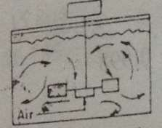

**Plate 2.0: Conventional turbine aerator** (Source: Agunwamba, 2000)

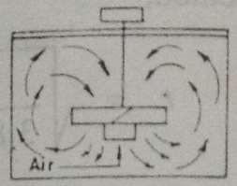

**Plate 2.1: Trans-flo turbine aerator** (Source: Agunwamba, 2000)

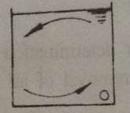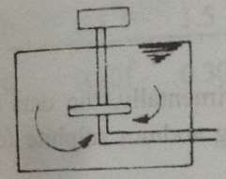

**Plate 2.2: Diffused aeration** (Source: Agunwamba, 2000)

**Plate 2.3: Submerged turbine aeration** (Source: Agunwamba, 2000)

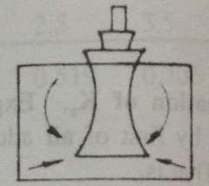

**Plate 2.4: Surface aeration** (Source: Agunwamba, 2000)

* + 1. Types of Aeration

Aeration can also be said to be the diffusion of air into the wastewater. The following are the two major types of aeration;

* + - 1. Bubble aeration: This is the introduction of air under pressure through porous or perforated distributors, turbines, injectors, impingement bowls or venturi which is classified as dispersed air systems (Agunwamba, 2000). The diffused and submerged aeration method is known as the bubble aeration method (Plate 2.2 and Plate 2.3 above). This group may further be separated into the fine and large bubble aerators. The fine bubble diffusers have high surface area/volume ratio and it achieves good transfer while the large bubble diffuser has a low surface area/volume ratio but it is cost efficient and does not clog easily (Agunwamba, 2000). The bubble diffusers are shown in the diagram below.

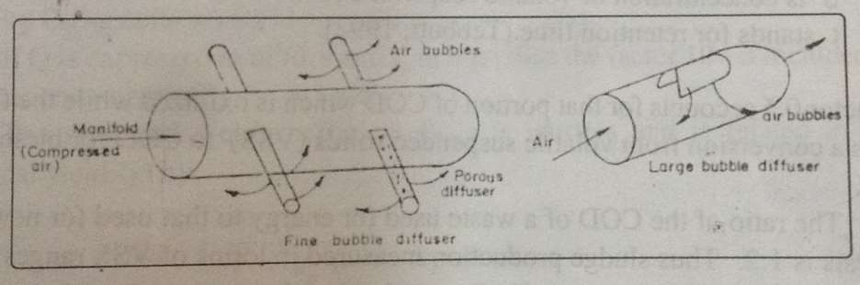

**Plate 2.5: Fine bubble and Large bubble diffusers** (Source: Agunwamba, 2000)

* + - 1. Mechanical aeration: In this type of aeration, the top surface of the liquid is skimmed and placed through the air in such a way that the particles fall within the confines of the tank. The sewage particles are aerated in as they pass through the air. As the aerated particles fall back on the surface, further mixing takes place and the bubbles of air are forced downward into the tank. Different factors affect the rate of mixing and they include; temperature, depth of tank, chemical composition of the sewage, depth of submergence and the nature of aeration device.

## Wastewater

Wastewater is not just sewage. It is all the water used in the home that goes down the drains or into the sewage collection system. This includes water from showers, baths, sinks, dishwaters, washing machines and toilets. As stated earlier, the point of interest of this study is to study the wastewater gotten from the toilets. Small businesses and industries often contribute large amounts of wastewater to sewage collection systems; others operate their own wastewater treatment systems.

Note: sewage is a type of wastewater that comprises of domestic wastewater and is therefore contaminated with feces or urine from the toilets, but the term sewage is also used to mean any type of wastewater.

* + 1. Constituents of wastewater

The composition of wastewater varies widely. Below is a partial list of what wastewater contains;

* It is made up of 95% water.
* Pathogens such as; bacteria, viruses and parasitic worms.
* Non-pathogenic bacteria
* Organic particles such as; feces, hairs, food etc.
* Inorganic particles such as; sand, grit etc.
* Soluble organic materials such as; urea, fruit sugars, soluble proteins and drugs.
* Soluble inorganic materials such as; ammonia, road salt, sea salt, cyanide, hydrogen sulphide and thiosulfates.
* Animals such as; protozoa, insects, arthropods etc.
* Gases such as; carbon dioxide, methane etc.
* Toxins such as; pesticides, poisons, herbicides etc.
  + 1. Types of wastewater

1. Domestic wastewater: This is wastewater that comes primarily from individuals, and does not generally include industrial or agricultural wastewater.
2. Industrial wastewater: This is wastewater that comes from industries, factories, automotive repair stores and car wash that may contain toxic or hazardous constituents.

## Wastewater Treatment

There are three major types of wastewater treatment which includes;

1. Primary treatment: It is the removal of floatable and settle able solids. This process involves;
   * Screening: This helps to remove large objects, such as stones or sticks that could plug lines or block tank inlets.
   * Grit chambers: This slows down the flow to allow grit to fall out.
   * Sedimentation tank: this helps the settle able solids to settle out and is pumped away, while oils float to the top and are skimmed off.
2. Secondary treatment: It is the biological removal of dissolved solids from the wastewater after it has gone through the primary treatment process.
3. Tertiary treatment: This is the use of advance treatment methods to remove nutrients such as nitrogen and phosphorus from the wastewater. These methods used can be physical, biological and chemical treatment.

Biological treatment of wastewater takes place in a fixed media or suspended growth reactors using activated sludge, bio-filtration, rotating biological contractors and constructed wetlands. Nitrification/denitrification and biological phosphorus removal can be incorporated in this stage and this will help reduce the nutrient concentrations in the outflow (EPA, 1997).

Chemical treatment is used to improve the settling abilities of suspended solids prior to a solids removal stage or to adjust the properties or components of waste water prior to biological treatment (EPA, 1997). Sludge treatment can be an important part of wastewater treatment steps and it involves the stabilization of sludge in anticipation of reuse or disposal.

Below are diagrams showing a typical wastewater treatment facility, wastewater treatment plant and municipal sewer systems.

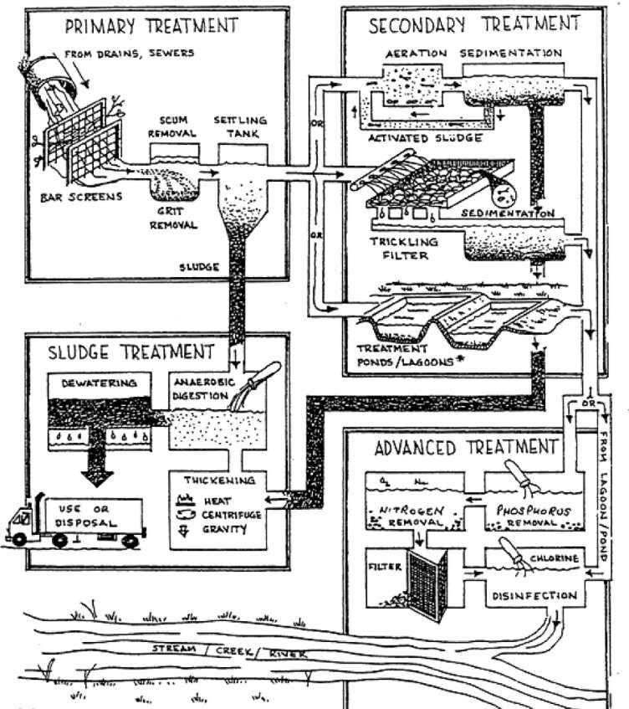

### Figure 2.1: Typical wastewater treatment facility

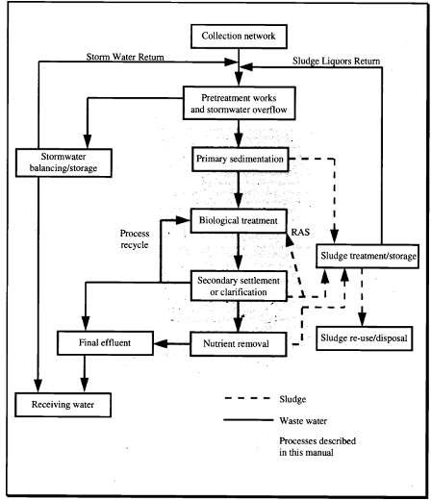

**Figure 2.2: Wastewater treatment plant overview**

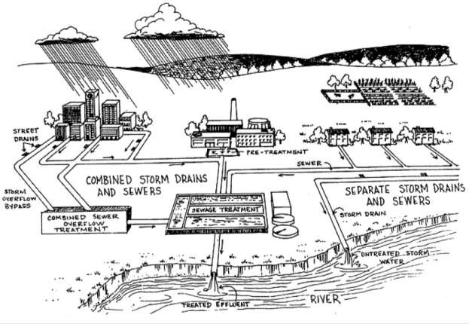

**Figure 2.3: Municipal Sewer facility**

* + 1. General Considerations for the Treatment of Wastewater

The strength of wastewater is normally measured using accurate analytical techniques. The more common analysis used includes;

1. BOD5
2. COD
3. TSS
4. pH
5. Total phosphorus
6. Total nitrogen
7. TDS
8. Total Coliform
   * 1. Parameters for measuring wastewater

Biochemical oxygen demand (BOD): This is the measure of oxygen required by micro- organisms while consuming organic matter in a wastewater specimen (EPA, 1997). The first step in measuring BOD is to obtain equal volumes of water from the area to be tested and dilute each specimen with a known volume of distilled water which has been thoroughly shaken to insure oxygen saturation.

Generally, when BOD levels are high, there is a decline in dissolved oxygen levels. This is because the demand for oxygen by the bacteria is high and they are taking that oxygen from the oxygen dissolved in the water. If there is no organic waste present in the water, there would not be as many bacteria present to decompose it and thus the BOD will tend to be lower and the dissolve oxygen level will tend to be higher. Factors that can influence this test includes; temperature of incubation, dilution rate, nitrification, toxic substance, nature of bacterial seed and presence of anaerobic organisms.

### Table 2.0: BOD and Water Quality

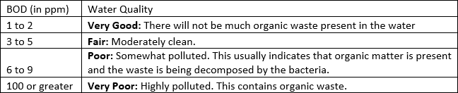

Chemical oxygen demand (COD): It is the measure of the oxygen-depletion capacity of a water specimen contaminated with organic waste matter. COD test will give a good estimate of the first stage oxygen demand for most wastewaters. An advantage of the COD over the biochemical oxygen demand (BOD) test is 2 to 3 hours versus 5 days. COD is used to measure the strength of wastes that are too toxic for the BOD test. The COD test should be taken as an independent measurement and not a quick replacement for BOD. The COD is usually higher than the BOD, but the amount will vary from waste sample to waste sample. The COD test should be considered as an independent measurement of organic matter in a sample rather than a substitute for the BOD test.

Chemical Oxygen Demand measures the capacity of hot chromic acid solution to oxidize organic matter. This analyzes both biodegradable and non-biodegradable organic matter. The results of the COD (chemical oxygen demand) tests are usually greater than that of the corresponding BOD test for several reasons. Many organic compounds which are dichromate oxidizable are not biochemically oxidizable; certain inorganic substances such as; sulphides, sulphates, thiosulphates, nitrites and ferrous iron are oxidized by dichromate, creating an inorganic COD, which is misleading when estimating the organic content of the wastewater.

Total suspended solids: This includes all particles suspended in water which will not pass through a filter ([NDDH,](http://www.ndhealth.gov/) 2016). This also represents the solids that are in suspension in the water. It is generally comprised of 70% organic and 30% inorganic solids and can be removed by physical or mechanical means (EPA, 1997).

PH: This is a term used to describe the relative amount of acidity or basicity in the wastewater. Low pH values indicate a high concentration of hydrogen ions (acids) in solution and high pH values indicate a low concentration of hydrogen ions (basic). The pH value can range from 1 to 14 with a value of 7 being neutral. The ideal pH in wastewater will typically be around the neutral range as seen in table 2.1.

### Table 2.1: Ideal range for pH in wastewater

Also, if the pH of the wastewater is outside the range of 5 – 10, there may be considerable interference with biological processes. Figure 2.4 illustrates the effect of pH on bacterial growth.

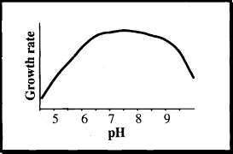

**Figure 2.4: Growth rate of micro-organisms as a function of pH**

Total Phosphorus: This is divide into three phases namely;

* Orthophosphate: This has to do with dissolved inorganic phosphate (PO43-)
* Polyphosphate: This has to do with complex compounds derived from detergents.
* Organically found phosphates: This has to do with dissolved and suspended organic phosphate.

Total Nitrogen: This refers to the sum of measurements of total oxidized nitrogen and total nitrogen.

Total Dissolve Solids: It is the total amount of mobile charged ions, including minerals, salts (principally calcium, magnesium, potassium, sodium, bicarbonates, chlorides and Sulphate) or metals dissolved in a given volume of water, expressed in units of mg per unit volume of water (mg/l), also referred to as parts per million (ppm). Total dissolve solids in drinking-water originate from natural sources, sewage, urban runoff and industrial wastewater. Concentrations of TDS in water vary considerably in different geological regions owing to differences in the

solubility of minerals. Note: High TDS level generally indicates hard water, which can cause scale buildup in pipes and filters thereby reducing its performance and increasing maintenance cost.

According to Ela, 2007; water can be classified according to the amount of TDS per liter present in it:

1. Fresh water < 1,500 mg/L TDS
2. Brackish water 10 to 3,000 mg/L TDS
3. Saline water 3,000 to 5,000 mg/L TDS
4. Brine > 5,000 mg/L TDS

Total Coliform: This includes bacteria that are found in the soil, in water that has been influenced by surface water, and in human or animal waste.

## Disinfection

Disinfection is considered to be an essential component for the inactivation/pulverization of pathogenic life forms to keep the spread of diseases and of which some of the organisms are required for degradation in septic tanks (Agunwamba et. al., 2013).

Disinfection of wastewater is the destruction of disease bearing pathogens (EPA, 1997). The pathogenic micro-organisms to be removed from wastewater during disinfection includes; fecal coliforms, streptococci, salmonella and enteric viruses. With the end goal of disinfection being effective, wastewater must be pretreated to remove suspended solids and organic materials. If an endeavor is made to disinfect treated wastewater, and it is not done properly, the organic compounds can „steal‟ the disinfectant and allow pathogens to survive (Agunwamba et. al., 2013).

A perfect disinfectant would offer complete microbial sterilization without harming micro- organisms. However, most disinfectants are also, by nature, potentially harmful to micro- organisms, humans and animals. The choice of disinfectant to be used depends on the particular situation. A few disinfectants have a wide range of killing many different types of micro- organisms while others kill a smaller range of disease-causing organisms but are preferred for other properties (DOH, 2016).

Disinfectants are widely used in homes, kitchens, hospitals and other health centers to control the growth of microbes on inanimate objects (Saha et. al., 2009). Commonly used disinfectant in homes and eateries include; Dettol, Izal, Harpic, Hydrogen peroxide, formalin etc. Below is a figure showing the various types of disinfectants.



### Figure 2.5: Various types of disinfectants

* + 1. Disinfection Techniques

The main techniques for the disinfection are divided into two categories namely;

* Chemical
* Physical

Chemical disinfection technique

Chemical disinfection includes; chlorine, ozone and hydrogen peroxide. Chlorine is very effective for removing almost all microbial pathogens and is appropriate as both primary and secondary disinfectant. Chlorine is applied in a number of forms which includes; chlorine gas, sodium hypochlorite and calcium hypochlorite. Chlorination of wastewater can result in the production of toxic compounds which can have long-term adverse effects on the beneficial uses of the water. Gray, 1989 quotes dosing rates ranging from 2 to 15 mg Cl2/L, depending on how much treatment the wastewater has received and contact times of 20 – 30 minutes. Ozone gas can be used in disinfection even though it does not leave a residual in the water being treated. Ozone reacts with organic matter in the wastewater and this ozone demand must be satisfied before efficient disinfection commences. Disinfection is typically achieved within 5 minutes as dosage rates of 5 – 50 mg O3/L, depending on the level of treatment received by the wastewater (EPA, 1997).

Other chemicals used in disinfection include;

* Aldehydes
* Phenolic
* Chlorites
* Acetic acid and carbonates

Below is a figure showing the process involved in chlorination using the cylinder-mounted chlorinator.

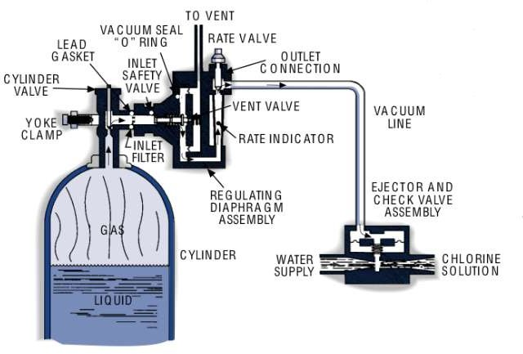

### Figure 2.6: Chlorination process using the cylinder-mounted chlorinator

Physical disinfection technique

This relies on enhanced removal of solids and membrane technologies. Ultra violet light is the principal method of irradiation. Ultra violet radiation is generated by a special lamp. When it penetrates the cell wall of an organism, the cell‟s genetic material is disrupted and the cell is unable to reproduce. Below is a figure showing an ultraviolet water purifier.

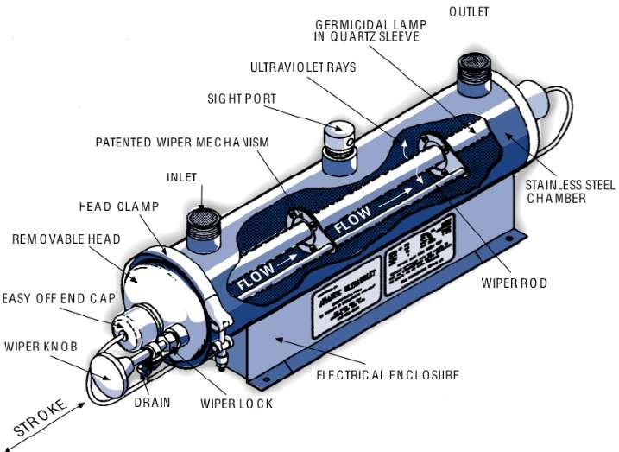

### Figure 2.7: Ultraviolet Water Purifier

* + 1. Effects of Disinfectants on Bacterial growth

The effect of disinfectant on bacterial growth is going to be limited to the various techniques used in disinfection.

* + - 1. Physical Disinfectant effect: The effect of ultraviolet rays, particularly rays discharged by the sun affects bacterial growth by altering bacteria‟s DNA to the extent that the micro- organisms are unable to reproduce. All micro-organisms need moisture to survive. The removal of moisture causes the bacteria to shrivel up and die. Heat is a valuable and readily available physical disinfectant that kills bacteria.
      2. Chemical Disinfectant effects: This affects the growth of micro-organisms by attacking the cellular components of the micro-organisms required to survive and reproduce. Most chemical antibacterial agents work by denaturing proteins or disrupting the cell membranes of the bacterial cells.
    1. Factors influencing the effects of disinfectant on bacterial growth

Different factors influence the effect of disinfectant on bacterial growth and they include;

* Type of bacteria: The type of bacteria present in the substance in which a particular disinfectant is going to be used is of utmost importance because if the disinfectant is weak, then no job has been done in sterilizing the substance and this causes the user to bring in a more effective/stronger disinfectant which may not be friendly to the micro- organisms present in this substance.
* Time: Some disinfectants work rapidly on a substance when applied to it while others require more time to act.
* Physical characteristics: The physical characteristics of the substance being disinfected are of utmost importance. The use of ultraviolet light as a disinfectant is limited to smooth surfaces because the rays are unable to effectively penetrate those that are porous.
* Efficiency of mixing: This has to do with the rate at which the disinfectant is able to mix properly with the substance during application. If mixing is not done properly, then a particular part of the substance will be disinfected while the other part will not be disinfected.
* The type of concentration of the chemicals.

## Camphor

Camphor is a waxy, flammable, white and transparent solid with strong aromatic odor. It has a chemical formula of C10H16O. Camphor is found in wood – Camphor laurel (Cinnamomum Camphora). Cinnamomum Camphora is grown in China, Taiwan, Japan, Sri Lanka and California in USA. The tree has a height of 30m (100 ft). Camphor can be synthetically produced from oil turpentine and its IUPAC name is 1, 7, 7-Trimethylbicyclo (2.2.1) heptan-2-one (Zuccarini and Soldani, 2009).

Camphor is a volatile inorganic crystalline substance that is used in the production of explosives and pest deterrent (Eweka et. al., 2008). It is also used as a mixture for medicinal purposes.

As stated by Budavari, 1989; Reynolds, 1989; “Camphor can also be produced synthetically from vinyl chloride and cyclopentadiene, passing through the intermediate dehydronorbornyl

chloride. The naturally occurring form is dextrorotatory and the synthetic form is optically inactive”. The figure below shows the structural formula of camphor.

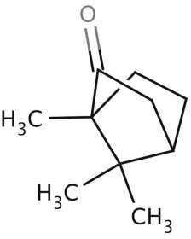

### Figure 2.8: Structural formula of camphor

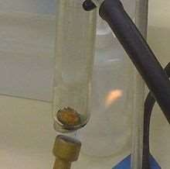

**Figure 2.9: Sublimed camphor**

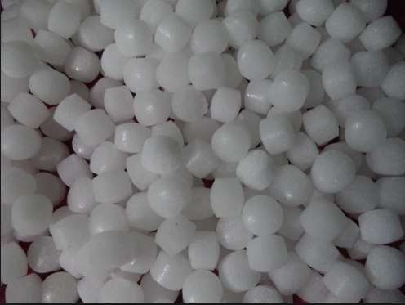

**Figure 2.10: Camphor**

* + 1. Physical Properties of Camphor

1. It has a chemical formula of C10H16O
2. It has a molar mass of 152.24gmol-1
3. Appearance – white, translucent crystals
4. Odor – fragrant and penetrating
5. It has a density of 0.992gcm-3
6. It has a relative vapor density of 5.2
7. Its melting point is between 175 to 177oC (347 to 351oF and 448 to 450K)
8. Auto-ignition temperature: 466oC
9. Flash point: 65oC
10. Its boiling point is at 209oC (408oK; 482oK)
11. Solubility in water: 1.2gdm-3
12. Solubility in acetone: 2500gdm-3
13. Solubility in acetic acid: 2000gdm-3
14. Solubility in diethyl ether: 2000gdm-3
15. Solubility in chloroform: 1000gdm-3
16. Solubility in ethanol: 1000gdm-3
17. Log p: 2.089
18. Vapor pressure: 4mmHg (at 70oC)
19. Chiral rotation: +44.1o
20. Explosive limits: 0.6 to 3.5 vol. in air
    * 1. Other Characteristics of Camphor
21. Shelf-life of the substance: 5 years
22. Storage conditions: store in air tight containers at a temperature not above 25oC
23. Specific properties and composition: strong aromatic odor.
    * 1. Uses of Camphor
    * It is used in making explosives
    * It is used in making pest deterrent and preservative
    * It is used for culinary purposes
    * It is used for medicinal purpose
    * It is also used for religious ceremonies
    * It is used as a rubefacient
    * It is used as a plasticizer for cellulose esters and ethers
    * It is used in lacquers and vanishes
    * It is used in the manufacture of cymene.
      1. Production of Camphor

Camphor can be produced from alpha-pinene, which is present in the oils of coniferous trees and can be distilled from turpentine produced as a side product of chemical pulping.

* + 1. Reactions

Camphor has different reactions with other chemical elements. Typical camphor reactions are;

* + Bromination
  + Oxidation with nitric acid
  + Conversion to isonitrosocamphor

Below are figures showing the different reactions camphor has with other elements.

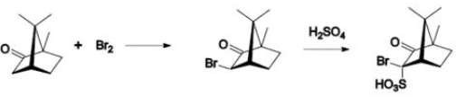

### Figure 2.11: Bromination

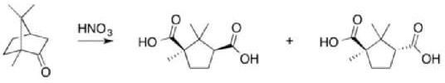

**Figure 2.12: Oxidation with nitric acid**

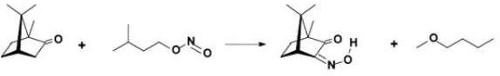

**Figure 2.13: Conversion to isonitrosocamphor**

* + 1. Effects of the various constituents of Camphor on bacteria life Camphor is composed of different chemical elements which includes;

1. Piperitone
2. Terpinen-4-ol
3. Eugenol
4. Caryophyllene
5. B-pinene & A-pinene
6. Geraniol
7. Camphene
8. Cinnamaldehyde
9. Sabinene
10. Linalool
11. P-cymene
12. Y-terpinene
13. Furfural
14. 1,8-Cineole
15. Borneol
16. Limonene
17. Borny acetate
18. Phellandrene
19. Methyl cinnamate
20. Safrole
21. Terpinolene

Most of these chemical elements do not have any effect on the bacteria found in sewage. Below are the list of the elements that have effects on bacteria life as stated in OECD, 1998; IUCLID, 2000:

* + Camphene: It causes a toxic effect on the bacteria found in sewage.
    - It is not biodegradable.
    - It is bio-accumulative.
    - It has a low toxicity with algae.
  + Terpinolene: It affects the respiration rate of the bacteria found in sewage and this is not good for bacteria.
  + A-pinene: This enables the growth of the bacteria found in sewage. Example of such bacteria is pseudomonas maltophilia.
  + Borneol: This enables the growth of the bacteria found in sewage.
  + Limonene: This also enables the growth of the bacteria found in sewage.
  + B-pinene: It is volatile in sewage.
    - It is also biodegradable.
    - It does not affect the bacteria found in sewage.
  + Sabinene: It is biodegradable and it disappears after 3 weeks in the sewage (Harder and Fob, 1999).
  + Phellandrene: It also does not have any effect on the bacteria found in sewage because it disappears from the sewage (Harder and Fob, 1999).
  + Eugenol: It helps the bacteria found in sewage to effectively degrade sewage (Li, 2011).

## Septic Tank

Septic systems are utilized to treat sewage in numerous areas that are not served by public sewers. According to MN Rules, 2016; “A septic tank means any water-weight, covered receptacle that is designed and constructed to receive the discharge of sewage from a building sewer or preceding tank, it stores liquids for a detention period that provides separation of solids from liquid and digestion of organic matter, and allows the effluent to discharge to a succeeding tank, treatment device, or soil dispersal system”. A septic tank is made up of concrete, fiberglass, polyethylene or plastic. The tank is buried underground at individual homes or buildings. Sewage flows through the pipes that connect the septic tank to the building **(The water source book)**. Clarified septic tank effluent exits the septic tank and enters the soil absorption system where a biological “clogging mat” or “biomat” forms, contributing to even distribution of the waste into the drain field (U.S. EPA, 1980a; Hoover et. al., 1996).

There are different treatment processes that occur in the septic tank and this includes;

* Physical processes
* Biological and chemical processes
  + 1. Physical Processes

Septic tanks allow the separation of solids from wastewater as heavier solids settle and fats, greases, and lighter solids float. The solid content of the wastewater is reduced by 60 – 80% within the tank. The solids that settles in the tank are called sludge, the floated solids are called scum, and the liquid layer in between is called the clear zone. Another function of the tank is also for the storage of accumulated solids. Below is a figure showing the physical processes and the components of a septic tank.

### Fig. 2.14: Diagram showing the physical processes and components of a septic tank.

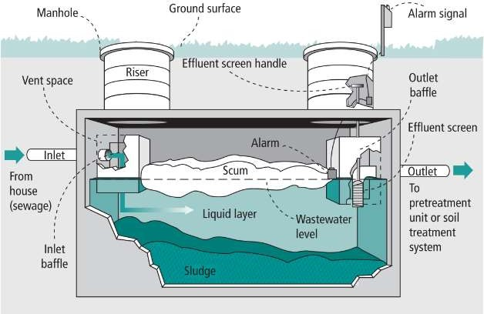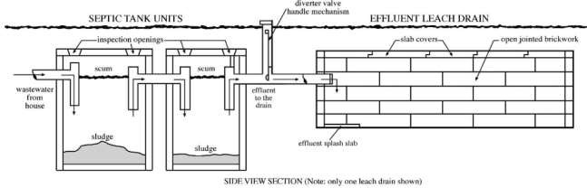

* + 1. Biological and Chemical processes

Solids in the septic tank include both biodegradable and non-biodegradable materials; although many of the solids will decompose, some solids will accumulate in the tank. Anaerobic and facultative biological processes in the oxygen-deficient environment of the tank provide partial digestion of some of the wastewater components (MN Rules, 2016). The anaerobic bacteria found in the septic tank breaks down the solid sewage into the following; water, carbon-dioxide, hydrogen sulphide and methane. The undigested residue (sludge) stays on the bottom of the tank and the scum floats to the top. The effluent from the septic tank containing the remaining liquid waste flows through a piping network to a drain field. Here, perforated pipes surrounded by gravel or sand slowly release the wastewater into the soil where bacteria and the roots of vegetation above finish the treatment process.

* + 1. Treatment achieved with domestic sewage

Septic tanks give essential anaerobic treatment (dissolved oxygen which is < 0.5 mg/L) in an onsite sewage treatment system of the raw wastewater. The discharge from the septic tank is typically treated so that it contains 140 to 220 milligrams per liter BOD, 45 to 70 milligrams per liter TSS, and 10 – 30 milligrams per liter FOG (Fats, oils and greases).

* + 1. Factors affecting septic tank performance

The anaerobic digestion processes in tanks are affected by temperature in the tank and by substances that have an adverse impact on biological organisms. Higher temperatures will enhance the rate of biological processes and inhibiting substances will reduce it. Some factors that affect the way a tank functions include;

* pH
* Strength of the incoming wastewater
* Introduction of harsh chemicals such as; drain cleaners, paint etc.
* Introduction of fats, oils and grease
* Highly variable flow patterns that affects detention time
* Introduction of pharmaceuticals
* Introduction of process discharge, including backwash from a water softener.
* Lack of maintenance resulting in excess accumulation of solids, reducing effective volume and reducing detention time.

# CHAPTER 3

## METHODOLOGY

## Introduction

This chapter entails how all the information used for this project was gathered. The activities involved in the process of carrying out this research consisted of a brief interview of restaurant workers in different restaurants located in Ota, Ogun State, Nigeria and collection of waste samples for analysis in the laboratory. Also, observations during the course of the experiment were duly noted. The methods chosen for this research were specifically tailored to facilitate the fulfillment of the aims and objectives of the research.

## Sample Collection and Preservation

The sewage sample was collected from the septic tank and placed inside a 25 liters container which was taken to the laboratory for analysis. Collection and preservation of the sewage sample for analysis was done according to the purpose for which the analysis is intended.

## Methods for Analysis

Different physical and bacteriological test would be carried out in order to effectively study the waste sample gotten from the restaurant in order to determine the effect of camphor on aerobic sewage degradation. Six (6) containers were used for the setup in the laboratory and the containers were properly washed using non-sulphate containing detergent. The containers were properly labelled using a numeric method of 1 to 6 as shown below;

* + - Container 1
    - Container 2
    - Container 3
    - Container 4
    - Container 5
    - Container 6 – Control

Container 1 to 5 represents the containers that will contain a particular dosage of camphor while container 6 is for control. The sewage samples were poured into the 5 litres containers and filled to the 2ltr mark of the container. The container was left open in other to allow for oxygen to circulate in it (Aerobic method).

The type of camphor used was **Blue Diamond Naphthalene camphor**. The camphor was crushed into powder form in other to get a good surface area ratio when added into the sewage sample. The weight of the camphor was taken and the dosage of camphor in the sewage sample is shown below;

* + - Container 1 – 7.38g of camphor
    - Container 2 – 14.25g of camphor
    - Container 3 – 21.91g of camphor
    - Container 4 – 29.44g of camphor
    - Container 5 – 36.20g of camphor
    - Container 6 – Control (no camphor was added to it)

Below are the various methods used to analyze the sewage sample;

1. Hanna instrument edge multi-meter was used to carry out the physical test.
2. Standard test procedures for water analysis (APA, 1999) was used as a guide to carry out the bacteriological test.
   * 1. Hanna Instrument Edge Multi-meter

The multi-meter is an instrument which is used to carry out different physical test for water and waste water samples.

The following test were conducted on the sewage sample using the handheld multi-meter;

* + - pH
    - Temperature.
    - Total Dissolved Solid (TDS)

### Procedure

* + - Temperature/pH

The sampling container was washed using a non-sulphate containing detergent (Ariel) and dried. The sewage samples were brought into the laboratory using a 25 litres container that was also washed using a non-sulphate containing detergent. The samples were properly shook in the container before pouring them into the 4 litres sampling container. The sampling containers were

filled to the 2 litres mark. The pH/Temperature probe was properly cleaned and inserted into the Hanna instrument edge multimeter. The multimeter was switched on and allowed to boot. The probe was then calibrated using the standard buffer solution for pH (Solution 7.0). The sewage sample was stirred properly for homogeneity. The probe was then deep into the sewage sample and the readings for the pH at a particular temperature were recorded. The probe was cleaned after use.

* + - Total Dissolve Solids (TDS)/Temperature

The sampling container was washed using a non-sulphate containing detergent (Ariel) and dried. The sewage samples were brought into the laboratory using a 25 litres container that was also washed using a non-sulphate containing detergent. The samples were properly shook in the container before pouring them into the 4 litres sampling container. The sampling containers were filled to the 2 litres mark. The total dissolve solids (TDS) probe was properly cleaned and inserted into the Hanna instrument edge multimeter. The multimeter was switched on and allowed to boot. The probe was then calibrated using the standard solution for total dissolve solids (HI7031 & HI8031). The sewage sample was stirred properly for homogeneity. The probe was then deep into the sewage sample and the reading for TDS at a particular temperature was recorded. The probe was cleaned after use. The unit for TDS is milligram per litre (mg/l).

Below are the pictures of the multi-meter.

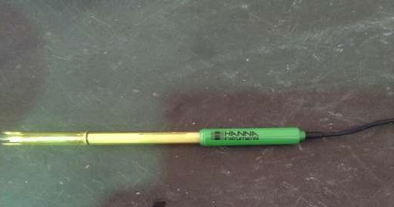

Plate 3.1: Hanna Instrument TDS/EC/Temperature probe.

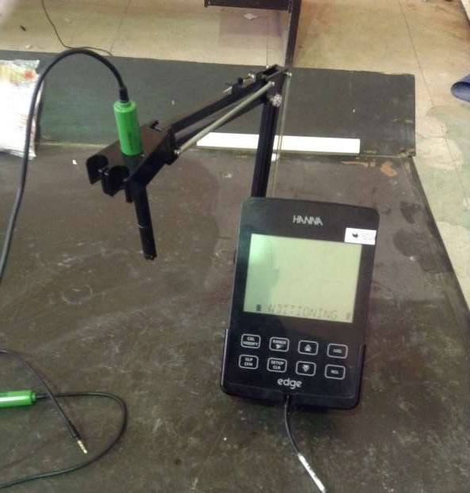

Plate 3.2: Hanna Instrument Edge Multi-meter.

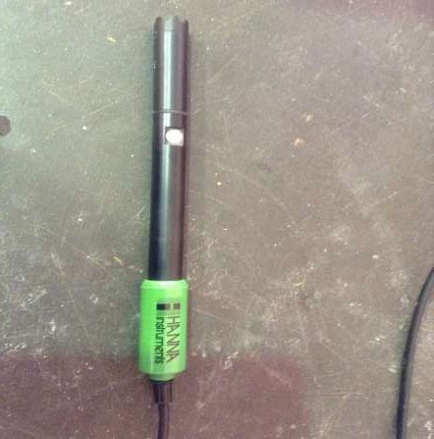

Plate 3.3: Hanna pH/Temperature probe.

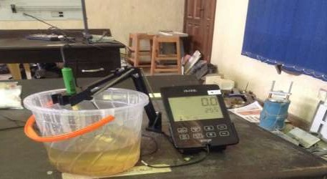

Plate 3.3b: Hanna Instrument Edge Multi-meter.

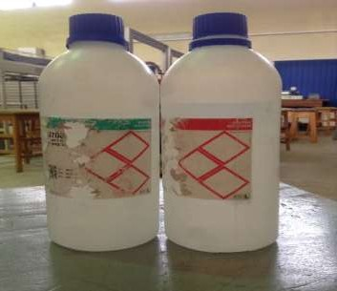

Plate 3.4: Hanna pH buffer solution.

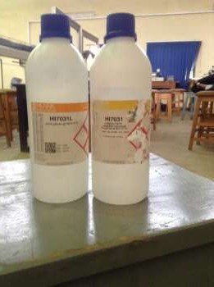

Plate 3.5: Hanna TDS Calibration solution.

* + 1. Standard Test Procedures

The test procedures were gotten from the Standard Analytical Procedures for Water Analysis (APA, 1999) and American water works association research foundation (1999). The test was carried out in duplicate and the average of each reading/result was taken in other to get accurate results. The following test would be conducted on the sample;

* + - Total Coliform
    - Bacteria count and
    - Total Suspended Solid (TSS)

### Total Coliform Apparatus

* + - Autoclave, for operation at a temperature of 121oC.
    - Sterilizer oven, to maintain a temperature of 160 -170oC
    - Incubator, to maintain a temperature of 35 oC ± 0.5oC
    - Glassware: fermentation tubes should have a capacity of 30 - 40 mL with aluminium caps, vials 0.25 - 0.5 mL capacity, pipettes 10 and 1 mL with 0.1 mL graduations.
    - Inoculating wire loop: 22 - 24 gauge nickel alloy wire loop 3 - 3.5 mm diameter for flame sterilization.

### Reagents and Culture medium:

* + - 1. Dilution water: Dissolve 34.0 g potassium dihydrogen phosphate, KH2PO4, in 500 mL distilled water and adjusted to pH 7.2 ± 0.5 with 1N sodium hydroxide and dilute to 1L. Distribute at the rate of 9 mL/tube. Close tubes with caps and sterilize.
      2. Lauryl tryptose broth: The ingredients are added to water, mixed thoroughly and heated to dissolve. pH should be 6.8 + 0.2 after sterilization. Before sterilization, dispense sufficient medium (approximately 10 mL) in fermentation tubes, in which inverted vials are placed (to cover the vial at least two thirds after sterilization, it may be completely submerged also). Close the tubes with caps and sterilize.

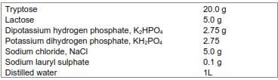

* + - 1. Brilliant green lactose bile broth:

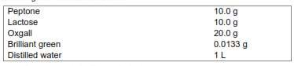

Prepare, dispense and sterilize as in b above.

### Note:

* + - Pre-formed dry powder medium available commercially for both b and c may be used.
    - Double the strength of medium if 10 mL inoculum is used.

The following steps are taking in other to get accurate results;

* Sterilization: The Cultured broths and distilled water were sterilized in the autoclave machine, at a temperature of 121oC for 15 min, and pipettes in canister were also sterilized in the hot air oven at a temperature of 170oC for 3hours.
* Presumptive test: The sewage sample was inoculated in the lactose broth tubes. The series of tubes may comprise of three or four groups of three, five or more tubes. The more tubes used, the more sensitive the test. Gas production in any one of the tubes is presumptive affirmation of the presence of coliforms. The most probable number (MPN) of coliforms in 100 ml of the water sample can be estimated by the number of positive tubes (see MPN Table).
* The Confirmed Test: If the tubes inoculated with the sewage sample produce gas, the sample is presumed to be unsafe. Nonetheless, it is possible that the formation of gas may not be due to the presence of coliforms. In order to confirm the presence of coliforms, it

is necessary to inoculate Eosin Methylene Blue (EMB) agar plates from a positive presumptive tube. The EMB agar inhibits Gram-positive organisms and allows the Gram- negative coliforms to grow. Coliforms produce colonies with dark centers. *Escherichia coli* (*E.coli)* and *Escherichia aerogenes (E.aerogenes)* can be distinguished from one another by the size and color of the colonies. *E.coli* colonies are smaller and have a green metallic sheen, whereas *E.aerogenes* are larger pinkish colonies. If only *E.coli* or if both *E.coli* and *E.aerogenes* appear on the EMB plate, the test is considered positive. If only *E.aerogenes* appears on the EMB plate, the test is taken as negative. The reasons for these interpretations is that, *E.coli* is an indicator of fecal contamination, since it is not normally found in water or soil, whereas *E.aerogenes* is widely distributed in nature outside of the intestinal tract.

* The Completed Test: The completed test is made using the organisms which grew on the confirmed test media. These organisms are used to inoculate a nutrient agar slant and a tube of lactose broth. After 24 hours at a temperature of 37°C, the lactose broth is checked for the production of gas, and a Gram stain is made from organisms on the nutrient agar slant. If the organism is a Gram-negative, non-spore forming rod and produces gas in the lactose tube, then it is positive that coliforms are present in the sewage sample.

### Procedures First period Material:

* + - * 1. Nine tubes of double-strength lactose broth
        2. Pipette
        3. Sewage samples

**Procedure:** Presumptive Test

1. Sewage samples of 10ml, 1ml and 0.1ml were inoculated into three tubes of lactose broth respectively.
2. All inoculated tubes were incubated at a temperature of 37oC for 24 hours.

### Second period

**Material:** Eosin Methylene Blue (EMB) agar plates

**Procedure:** Presumptive Test

1. Check and observe properly the number of tubes that shows gas production in 24 hrs and record results.
2. Re-incubate for another 24 hrs. at a temperature of 37°C.

### Confirmed Test

1. Inoculation is carried out on a tube containing gas on the EMB plate.
2. The plate is inverted and incubated at a temperature of 37°C for 24 hrs.

### Third period Material:

1. Lactose broth tubes
2. Nutrient agar slants

**Procedure:** Presumptive Test

* + - Check the number of tubes at each dilution that show gas production. Record the results and determine the most probable number (MPN) index.

### Confirmed Test

* + - The Eosin Methylene Blue (EMB) agar plates is observed. A positive confirmed test is shown by small colonies with dark centers and a green metallic sheen *E. coli*. Record the results.

### Completed Test

* + - The lactose broth tube is inoculated and a nutrient agar slant with organisms from the EMB plate.
    - The broth tube is incubated alongside the agar slant at a temperature of 37°C for 24 hours.

### Fourth period

**Procedure:** Completed Test

* + - Gas production is checked for in the lactose broth tube.
    - Make a Gram stain from the organisms on the nutrient agar slant.
    - Record results.

Below is a diagram showing the table for the most probable number of the inoculum (MPN).

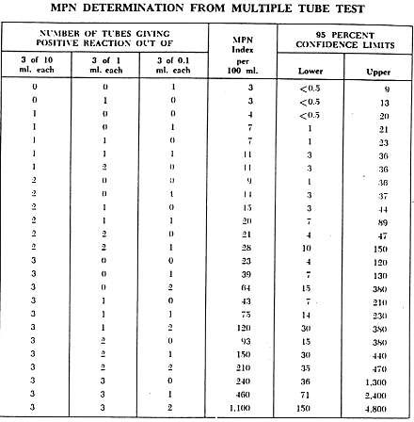

Fig 3.1: MPN Determination from Multiple Tube Test

Source: American water works association research foundation, (May 1999).

### Total Suspended Solids Apparatus

* Glass-fiber filter disk, Whatman grade 934 AH, Gelman type A/E, Millipore type AP4O or equivalent, diameter 2.2 to 12.5 cm.
* A Filtration apparatus, Membrane filter funnel or Gooch crucible with adapter and suction flask of sufficient capacity for sample size selected.
* An oven, 104 ± 1oC
* Weigh balance
* Weighing dishes made of aluminium.

### Procedure

* The filter paper is washed by putting it on a filtration assembly and filtering 3 successive 20 mL portions of distilled water.
* Place the filter paper in the aluminium dish and dry it in the oven at a temperature of 104

± 1oC for 1 h. If a Gooch crucible is used, dry filter and crucible together. Cool in desiccator to balance temperature and weigh.

* Assemble filtration apparatus with the washed, dried and weighed filter paper. Wet filter paper with a small amount of distilled water to seat it.
* The sample is stirred with a magnetic stirrer and while stirring pipette a measured volume on to the filter using a wide bore pipette. Choose sample volume to yield between 10 and 200 mg dried solids.
* Wash with 3 successive 10 mL volumes of distilled water. Continue suction for about 3min after filtration is complete.
* The filter is carefully removed and transfer to the aluminium-weighing dish. Dry, cool and weigh as in b above.

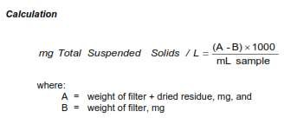

Below are pictures from the experiment.

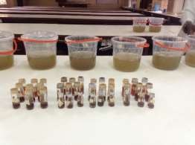

Plate 3.6: Sewage samples being prepare for coliform test.

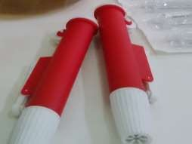

Plate 3.7: Pipette used for coliform test.

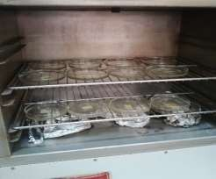

Plate 3.8: Sewage samples inside the oven for total bacteria count @ 37oC.

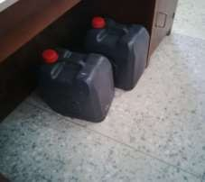

Plate 3.9: 25 liters containers used to convey the sewage samples to the laboratory.

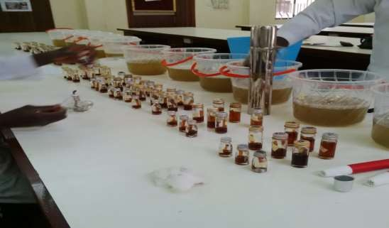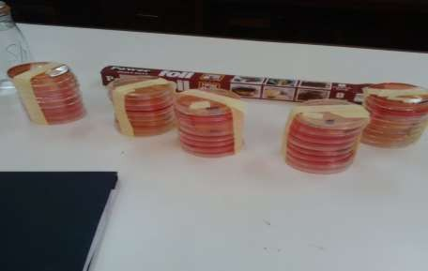

Plate 3.10: Aerobic sewage samples being prepared for coliform test.

Plate 3.11: Nutrient agar being used for bacteria count.

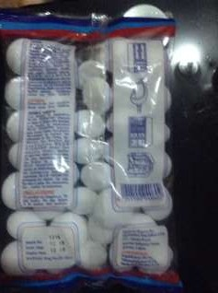

Plate 3.12: Blue Diamond Naphthalene Balls (Camphor) used for the experiment.

# CHAPTER 4

## RESULTS AND DISCUSSION

## Introduction

This chapter details, analyzes and discusses the results of all the experiments carried out as stated in the methodology in Chapter 3.

## Results and Discussion

In Table 4.1 and Chart 4.1, the results for the aerobic sample containing crushed camphor are reported for Week 1. The results gotten for the pH, shows that there was a decrease in the pH value for the sewage sample as compared with that of control. Thus, the sewage sample is alkaline (for all 3 days) which is as a result of the camphor mixing with the sewage. The result also shows a varying temperature range of 24.5oC to 28.85oC for Day 1; 24.5oC to 25.10oC for Day 2; 23.15oC to 24.4oC for Day 3. From previous studies, it has been observed that a good septic tank has to have a pH value of 6 to 7.5 which is the best range for microbial growth and a temperature value above 4.44oC for the aerobic bacteria to perform properly. Now looking at the data gotten from the results, only the temperature values are within the stipulated scale. The ambient temperature varied for the 3 days in week 1 as shown in Table 4.2 and Chart 4.2. Although, there was a decrease in the ambient temperature of the laboratory but this did not have any adverse effect on the experiment.

### Table 4.1: Average pH and Temperature for Week 1

|  |  |  |  |  |  |  |  |
| --- | --- | --- | --- | --- | --- | --- | --- |
| Sampling Container | Weight of crushed camphor (grams, g) | Day 1 | | Day 2 | | Day 3 | |
| pH | Temp  (oC) | pH | Temp  (oC) | pH | Temp  (oC) |
| 1 | 7.38 | 7.81 | 25.10 | 7.81 | 25.10 | 8.31 | 24.40 |
| 2 | 14.25 | 7.81 | 24.60 | 7.81 | 24.60 | 8.30 | 23.45 |
| 3 | 21.91 | 7.68 | 24.50 | 7.68 | 24.50 | 8.22 | 23.15 |
| 4 | 29.44 | 7.59 | 28.85 | 7.59 | 24.85 | 8.22 | 23.95 |
| 5 | 32.2 | 7.61 | 24.95 | 7.61 | 24.95 | 8.21 | 24.15 |
| 6 | Control | 7.87 | 24.95 | 7.87 | 24.95 | 8.50 | 24.35 |

pH Values

**Table 4.2: Average Ambient temperature of the room in (oC) for Week 1.**

**Chart 4.1: Average pH for 3 days in Week 1**

8.6

8.4

8.2

8

7.8

7.6

7.4

7.2

7

Day 1

Day 2

Week 1

Day 3

Sample 1 Sample 2 Sample 3 Sample 4 Sample 5 Sample 6

Temperature

|  |  |  |  |  |
| --- | --- | --- | --- | --- |
| Day 1 – Temp (oC) | | Day 2 – Temp (oC) | Day 3 – Temp (oC) | |
| 26.6 | | 26.6 | 25.1 | |
|  | **Chart 4.2: Ambient Temperature in Week 1**  27  26  25  24  Day 1 Day 2 Day 3  Week 1  Temp. | | |  |

In Table 4.3 and Chart 4.3, the results for the aerobic sample containing crushed camphor are reported for Week 2. The results gotten for the pH, shows that there was a decrease in the pH value for the sewage sample as compared with that of control. Thus, the sewage sample is alkaline (for all 3 days) which is as a result of the camphor mixing with the sewage. The result also shows a varying temperature range of 22.55oC to 23.45oC for Day 1; 23.1oC to 24.0oC for Day 2; 23.95oC to 24.75oC for Day 3. From previous studies, it has been observed that a good

septic tank has to have a pH value of 6 to 7.5 which is the best range for microbial growth and a temperature value above 4.44oC for the aerobic bacteria to perform properly. Now looking at the data gotten from the results, only the temperature values are within the stipulated scale. The ambient temperature varied for the 3 days in Week 2 as shown in Table 4.4 and Chart 4.4. Although, there was an increase in the ambient temperature of the laboratory but this did not have any adverse effect on the experiment.

### Table 4.3: Average pH and Temperature for Week 2

**Chart 4.3: Average pH for 3 days in Week 2**

8.6

8.4

8.2

8

7.8

7.6

7.4

7.2

7

Day 1

Day 2

Week 2

Day 3

Sample 1 Sample 2 Sample 3 Sample 4 Sample 5 Sample 6

|  |  |  |  |  |  |  |  |
| --- | --- | --- | --- | --- | --- | --- | --- |
| Sampling Container | Weight of crushed camphor  (grams, g) | Day 1 | | Day 2 | | Day 3 | |
| pH | Temp (oC) | pH | Temp (oC) | pH | Temp (oC) |
| 1 | 7.38 | 8.12 | 23.55 | 8.08 | 24.00 | 8.01 | 24.75 |
| 2 | 14.25 | 8.03 | 23.00 | 8.09 | 23.40 | 8.00 | 24.30 |
| 3 | 21.91 | 8.01 | 22.75 | 8.05 | 23.10 | 8.00 | 24.05 |
| 4 | 29.44 | 8.03 | 22.55 | 8.07 | 23.10 | 8.03 | 23.95 |
| 5 | 32.20 | 8.01 | 22.75 | 8.08 | 23.25 | 8.03 | 24.25 |
| 6 | Control | 8.33 | 23.45 | 8.38 | 23.05 | 8.37 | 23.95 |

**Table 4.4: Average Ambient temperature of the room in (oC) for Week 2**

pH Values

|  |  |  |
| --- | --- | --- |
| Day 1 – Temp (oC) | Day 2 – Temp (oC) | Day 3 – Temp (oC) |
| 26.45 | 25.8 | 26.5 |

**Temperature**

In Table 4.5 and Chart 4.5, the results for the aerobic sample containing crushed camphor are reported for week 3. The results gotten for the pH, shows that there was an increase in the pH value of the sewage samples containing camphor for day 1, 2 & 3 as compared with that of control. Thus, the sewage sample is alkaline (for all 3 days) which is as a result of the camphor mixing with the sewage. The result also shows a varying temperature range of 23.0oC to 23.35oC for Day 1; 24.60oC to 25.10oC for Day 2; 24.6oC to 25.20oC for Day 3. From previous studies, it has been observed that a good septic tank has to have a pH value of 6 to 7.5 which is the best range for microbial growth and a temperature value above 4.44oC for the aerobic bacteria to perform properly. Now looking at the data gotten from the results, only the temperature values are within the stipulated scale. The ambient temperature varied for the 3 days in Week 3 as shown in Table 4.6 and Chart 4.6. Although, there was an increase and decrease in the ambient temperature of the laboratory but this did not have any adverse effect on the experiment.



**Chart 4.4: Ambient Temperature for Week 2**

27

26

25

Day 1

Day 2

**Week 2**

Day 3

Temp.

### Table 4.5: Average pH and Temperature for Week 3

|  |  |  |  |  |  |  |  |
| --- | --- | --- | --- | --- | --- | --- | --- |
| Sampling Container | Weight of crushed camphor  (grams, g) | Day 1 | | Day 2 | | Day 3 | |
| pH | Temp (oC) | pH | Temp (oC) | pH | Temp (oC) |
| 1 | 7.38 | 7.89 | 23.35 | 7.88 | 25.10 | 7.69 | 25.20 |
| 2 | 14.25 | 7.87 | 23.15 | 7.69 | 24.70 | 7.60 | 24.80 |
| 3 | 21.91 | 7.84 | 23.00 | 7.84 | 24.70 | 7.75 | 24.65 |
| 4 | 29.44 | 7.83 | 23.05 | 7.77 | 24.60 | 7.83 | 24.60 |
| 5 | 32.20 | 7.82 | 23.00 | 7.83 | 24.65 | 7.73 | 24.80 |
| 6 | Control | 7.63 | 23.15 | 7.45 | 25.05 | 7.00 | 24.80 |

pH Values

**Table 4.6: Average Ambient temperature of the room in (oC) for Week 3**

**Chart 4.5: Average pH for 3 days in Week 3**

8

7.8

7.6

7.4

7.2

7

6.8

6.6

6.4

6.2

6

Day 1

Day 2

Week 3

Day 3

Sample 1 Sample 2 Sample 3 Sample 4 Sample 5 Sample 6



**Chart 4.6: Ambient Temperature for week 3**

28

27

26

25

Day 1

Day 2

**Week 3**

Day 3

Temp.

**Temperature**

|  |  |  |
| --- | --- | --- |
| Day 1 – Temp (oC) | Day 2 – Temp (oC) | Day 3 – Temp (oC) |
| 27.20 | 26.6 | 25.95 |

In Table 4.7 and Chart 4.7, the results for the aerobic sample containing crushed camphor are reported for week 4. The results gotten for the pH, shows that there was an increase in the pH value for the sewage sample as compared with that of control. Thus, the sewage sample is

alkaline (for all 3 days) which is as a result of the camphor mixing with the sewage. The result also shows a varying temperature range of 24.6oC to 25.2oC for Day 1; 24.45oC to 25.60oC for Day 2; 24.2oC to 25.95oC for Day 3. From previous studies, it has been observed that a good septic tank has to have a pH value of 6 to 7.5 which is the best range for microbial growth and a temperature value above 4.44oC for the aerobic bacteria to perform properly. Now looking at the data gotten from the results, only the temperature values are within the stipulated scale. The ambient temperature varied for the 3 days in Week 4 as shown in Table 4.8 and Chart 4.8. Although, there was an increase in the ambient temperature of the laboratory but this did not have any adverse effect on the experiment.

**Chart 4.7: Average pH for 3 days in Week 4**

8

7.8

7.6

7.4

7.2

7

6.8

Day 1

Day 2

Week 4

Day 3

Sample 1 Sample 2 Sample 3 Sample 4 Sample 5 Sample 6

pH Values

### Table 4.7: Average pH and Temperature for Week 4

|  |  |  |  |  |  |  |  |
| --- | --- | --- | --- | --- | --- | --- | --- |
| Sampling Container | Weight of crushed camphor  (grams, g) | Day 1 | | Day 2 | | Day 3 | |
| pH | Temp (oC) | pH | Temp (oC) | pH | Temp (oC) |
| 1 | 7.38 | 7.69 | 25.20 | 7.79 | 24.70 | 7.74 | 24.85 |
| 2 | 14.25 | 7.60 | 24.80 | 7.69 | 24.45 | 7.67 | 24.20 |
| 3 | 21.91 | 7.75 | 24.65 | 7.77 | 25.10 | 7.72 | 25.95 |
| 4 | 29.44 | 7.83 | 24.60 | 7.76 | 25.60 | 7.71 | 24.05 |
| 5 | 32.20 | 7.73 | 24.80 | 7.67 | 25.25 | 7.61 | 24.35 |
| 6 | Control | 7.00 | 24.80 | 7.26 | 25.10 | 7.24 | 24.15 |

**Table 4.8: Average Ambient temperature of the room in (oC) for Week 4**



**Chart 4.8: Ambient Temperature for Week 4**

28

27

26

25

Day 1

Day 2

**Days**

Day 3

Temp.

**Temperaqture**

|  |  |  |
| --- | --- | --- |
| Day 1 – Temp (oC) | Day 2 – Temp (oC) | Day 3 – Temp (oC) |
| 25.95 | 25.90 | 27.4 |

Below is a picture taken in the laboratory during the use of the multimeter to take the pH, Temperature and TDS of the sewage sample

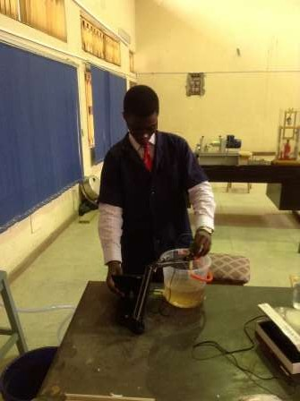

Plate 4.1: Use of the multi-meter to get the pH and TDS values of the sewage

sample.

In Table 4.9, 4.10, 4.11 and Figure 4.1, the results for the die-off rate of the bacteria present in the aerobic sample containing crushed camphor are reported for 28 days (4 Weeks). The bacteria removal rate for 14 days (Week 2) shows the amount of bacteria present in the sewage sample during the start of the experiment. The bacteria removal rate for 21 days (Week 3) shows a sudden decrease of the bacteria present in the sewage samples including control as shown in the graph. This could be as a result of the bacteria trying to position itself properly in the sample after the introduction of camphor. The bacteria removal rate for 28 days (Week 4) shows an increase in the amount of bacteria present in the sewage sample. This proves the fact that after 21 days, the bacteria was able to accommodate the camphor in the sewage and was still able to reproduce and carry out its main purpose of sewage degradation without allowing the camphor to make it inactive.

### Note: The formula used to calculate the die-off rate

Formula =

### Table 4.9: Bacteria removal rate @ 14 days

|  |  |  |  |  |  |
| --- | --- | --- | --- | --- | --- |
| Sampling Container | Weight of crushed camphor (grams,  g) | MPN for Day 3 Wk. 1 | MPN for Day 3 Wk. 2 | Die-off rate | % of die-off rate |
| 1 | 7.38 | 23 | 93 | 0.030 | 3 |
| 2 | 14.25 | 23 | 23 | 0 | 0 |
| 3 | 21.91 | 23 | 150 | 0.055 | 5.5 |
| 4 | 29.44 | 43 | 23 | -0.0046 | -0.46 |
| 5 | 32.20 | 23 | 23 | 0 | 0 |
| 6 | Control | 43 | 75 | 0.00744 | 0.744 |

**Table 4.10: Bacteria removal rate @ 21 days**

|  |  |  |  |  |  |
| --- | --- | --- | --- | --- | --- |
| Sampling Container | Weight of crushed  camphor (grams, g) | MPN for Day 3, Wk.  2 | MPN for Day 3, Wk.  3 | Die-off rate | % of die-off rate |
| 1 | 7.38 | 93 | 4 | 0.0096 | 0.96 |
| 2 | 14.25 | 23 | 9 | 0.0061 | 0.61 |
| 3 | 21.91 | 150 | 4 | 0.0097 | 0.97 |
| 4 | 29.44 | 23 | 4 | 0.0083 | 0.83 |
| 5 | 32.20 | 23 | 4 | 0.0083 | 0.83 |
| 6 | Control | 75 | 4 | 0.0095 | 0.95 |

**Table 4.11: Bacteria removal rate @ 28 days**

|  |  |  |  |  |  |
| --- | --- | --- | --- | --- | --- |
| Sampling Container | Weight of  crushed camphor (grams, g) | MPN for Day 3,  Wk. 3 | MPN for Day 3, Wk.  4 | Die-off rate | % of die-off rate |
| 1 | 7.38 | 4 | 75 | 0.1775 | 17.75 |
| 2 | 14.25 | 9 | 23 | 0.0156 | 1.56 |
| 3 | 21.91 | 4 | 23 | 0.0475 | 4.75 |
| 4 | 29.44 | 4 | 23 | 0.0475 | 4.75 |
| 5 | 32.20 | 4 | 23 | 0.0475 | 4.75 |
| 6 | Control | 4 | 1 | -0.0075 | 0.75 |

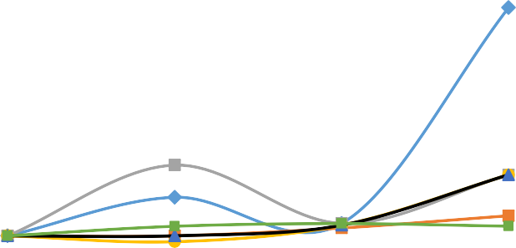

**Figure 4.1:** Bacteria Removal Rate for 4 weeks

20

15

10

5

0

0

1

2

3

4

5

-5

No. of Weeks

Sample 1

Sample 2

Sample 3

Sample 4

Sample 5

Sample 6

Bacteria Removal Efficiency in %

Below are pictures taken in the laboratory during the coliform test

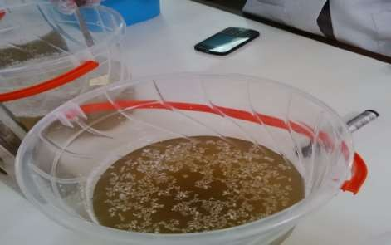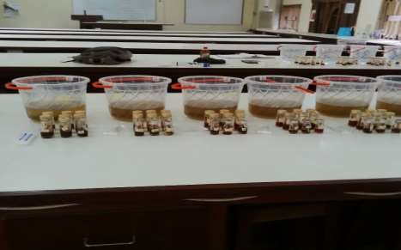

Plate 4.2a: Sewage sample containing crushed camphor.

Plate 4.2b: Sewage sample after inoculation (Coliform Test).

In Table 4.12, 4.13, 4.14 and Figure 4.2, the result of the total dissolve solids (TDS) of the aerobic sample containing camphor for 28 days (4 Weeks) was reported. The results shows the amount of total dissolved solids (TDS) present in the sewage samples at 14 days (Week 2) to be at a slightly stable level as shown in Figure 4.2 (TDS removal rate in percentage). From Table 4.12, it is seen that there was an increase in the amount of total dissolve solids (TDS) present in

the sewage sample when compared with that of the control. This shows that the bacteria is actually degrading the organic matter present in the sewage sample. At 21 days (Week 3), there was an increase in the amount of TDS present in the sewage sample as seen in the Figure 4.2. This increase was greater than that recorded during the Week 2 of the experiment. This shows that the camphor helped to enhance the bacteria in feeding on the organic matter present in the sewage sample. At 28 days (Week 4), it was observed that there was a considerable decrease of the amount of bacteria present. This implies that due to the high rate of degradation that occurred during the 21 days period, the bacteria had degraded all the organic materials present in the sewage and therefore since there was shortage of food, it led to most of the bacteria dying.

### Note: The formula used to calculate the TDS removal rate

Formula =

### Table 4.12: TDS removal rate @ 14 days

|  |  |  |  |  |  |
| --- | --- | --- | --- | --- | --- |
| Sampling Container | Weight of crushed camphor (grams,  g) | TDS for Day 3 Wk. 1 | TDS for Day 3 Wk. 2 | TDS Removal | % of TDS |
| 1 | 7.38 | 34 | 31 | 0.00088 | 0.088 |
| 2 | 14.25 | 36 | 31 | 0.00138 | 0.138 |
| 3 | 21.91 | 37 | 33 | 0.00108 | 0.108 |
| 4 | 29.44 | 37 | 33 | 0.00108 | 0.108 |
| 5 | 32.20 | 38 | 33 | 0.00132 | 0.132 |
| 6 | Control | 36 | 33 | 0.00083 | 0.083 |

**Table 4.13: TDS removal rate @ 21 days**

|  |  |  |  |  |  |
| --- | --- | --- | --- | --- | --- |
| Sampling Container | Weight of  crushed camphor (grams, g) | TDS for Day 3, Wk. 2 | TDS for Day 3, Wk. 3 | TDS  Removal | % of TDS |
| 1 | 7.38 | 31 | 27 | 0.0013 | 0.13 |
| 2 | 14.25 | 31 | 24 | 0.0023 | 0.23 |
| 3 | 21.91 | 33 | 30 | 0.0009 | 0.09 |
| 4 | 29.44 | 33 | 31 | 0.0006 | 0.06 |
| 5 | 32.20 | 33 | 28 | 0.0015 | 0.15 |
| 6 | Control | 33 | 27 | 0.0018 | 0.18 |

**Table 4.14: TDS removal rate @ 28 days**

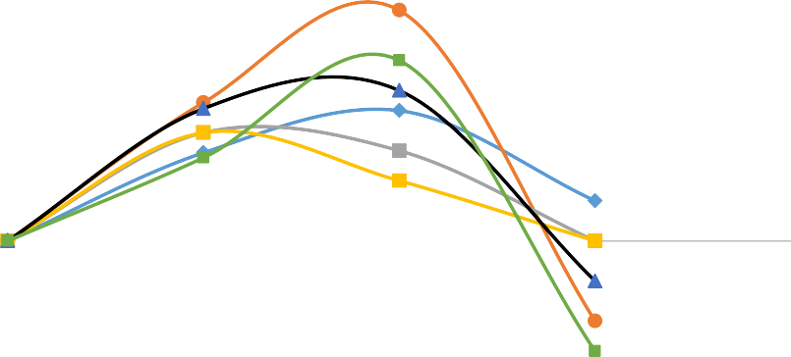

**Figure 4.2:** TDS Removal Rate for 4 weeks

0.25

0.2

0.15

0.1

0.05

0

5

-0.05

-0.1

-0.15

No. of Weeks

Sample 1

Sample 2

Sample 3

Sample 4

Sample 5

Sample 6

4

3

2

1

0

TDS Removal Efficiency in %

|  |  |  |  |  |  |
| --- | --- | --- | --- | --- | --- |
| Sampling Container | Weight of crushed  camphor (grams, g) | TDS for Day 3, Wk. 3 | TDS for Day 3, Wk. 4 | TDS  Removal | % of TDS |
| 1 | 7.38 | 27 | 26 | 0.0004 | 0.04 |
| 2 | 14.25 | 24 | 26 | -0.0008 | -0.08 |
| 3 | 21.91 | 30 | 30 | 0 | 0 |
| 4 | 29.44 | 31 | 31 | 0 | 0 |
| 5 | 32.20 | 28 | 29 | -0.0004 | -0.04 |
| 6 | Control | 27 | 30 | -0.0011 | -0.11 |

In Table 4.15, 4.16, 4.17 and Figure 4.3, the result of the total suspended solids (TSS) of the aerobic sample containing camphor for 28 days (4 Weeks) was reported. The result shows the amount of total suspended solids (TSS) present in the sewage samples at 14 days (Week 2) to be high in sample 2, and very low in sample 1, 3, 4 & 5 when compared with control as shown in Figure 4.3 (TSS removal efficiency rate in percentage). At 21 days (Week 3), there was an increase in the amount of TSS present in the sewage sample for sample 1, 3 & 4 as seen in Fig.

4.3. This increase was greater than that recorded during the Week 2 of the experiment. This shows that the bacteria was able to degrade the organic matter present in the sewage sample. Although, it should be noted that part of the crushed camphor that was unable to dissolve with

the sewage constituted part of the suspended solids. At 28 days (Week 4), it was observed that there was a considerable decrease of the total suspended solids present in the sewage sample when compared with the results gotten for 14 and 21 days. This implies that settling occurred in the sampling containers which reduced the number of suspended solids.

### Note: The formula used to calculate the TSS removal rate

Formula =

### Table 4.15: TSS removal rate @ 14 days

|  |  |  |  |  |  |
| --- | --- | --- | --- | --- | --- |
| Sampling Container | Weight of crushed  camphor (grams, g) | TSS for Day 3 Wk.  1 | TSS for Day 3 Wk. 2 | TSS Removal | % of TSS |
| 1 | 7.38 | 2 | 2 | 0 | 0 |
| 2 | 14.25 | 1 | 5 | 0.04 | 4 |
| 3 | 21.91 | 0 | 1 | 0 | 0 |
| 4 | 29.44 | 63 | 62 | -0.0002 | -0.02 |
| 5 | 32.20 | 169 | 269 | 0.0059 | 0.59 |
| 6 | Control | 1 | 2 | 0.01 | 1 |

**Table 4.16: TSS removal rate @ 21 days**

|  |  |  |  |  |  |
| --- | --- | --- | --- | --- | --- |
| Sampling Container | Weight of crushed camphor (grams,  g) | TSS for Day 3, Wk. 2 | TSS for Day 3, Wk. 3 | TSS  Removal | % of TSS |
| 1 | 7.38 | 2 | 4 | 0.01 | 1 |
| 2 | 14.25 | 5 | 2 | -0.006 | -0.6 |
| 3 | 21.91 | 1 | 6 | 0.05 | 5 |
| 4 | 29.44 | 62 | 97 | 0.0056 | 0.56 |
| 5 | 32.20 | 269 | 77 | -0.007 | -0.7 |
| 6 | Control | 2 | 2 | 0 | 0 |

**Table 4.17: TSS removal rate @ 28 days**

|  |  |  |  |  |  |
| --- | --- | --- | --- | --- | --- |
| Sampling Container | Weight of crushed camphor (grams, g) | TSS for Day 3, Wk.  3 | TSS for Day 3, Wk. 4 | TSS  Removal | % of TSS |
| 1 | 7.38 | 4 | 8 | 0.01 | 1 |
| 2 | 14.25 | 2 | 5 | 0.02 | 2 |
| 3 | 21.91 | 6 | 5 | -0.002 | -0.2 |
| 4 | 29.44 | 97 | 77 | -0.002 | -0.2 |
| 5 | 32.20 | 77 | 86 | 0.001 | 0.1 |
| 6 | Control | 2 | 2 | 0 | 0 |

In Table 4.18 and Figure 4.4, the result of the Total Bacteria Count (TBC) of the aerobic sample containing camphor for Week 1 was reported. The result shows the amount of bacteria present in the sewage samples for Week 1 (7 days) to be low in all samples when compared with control as shown in Figure 4.4. Table 4.18, also shows the various bacteria present in the sewage sample which includes*; Escherichia coli, Escherichia aerogenes*, aerobic bacteria, and salmonella shigella.



**Figure 4.3**: TSS Removal Rate for 4 weeks

6

5

4

3

2

1

0

0

1

2

3

4

5

-1

No. of Weeks

Sample 1

Sample 2

Sample 3

Sample 4

Sample 5

Sample 6

TSS Removal Efficiency in %

**Table 4.18:** Total Bacteria Count for the sewage sample for Week 1

|  |  |  |  |  |  |
| --- | --- | --- | --- | --- | --- |
| Sampling Container | Weight of crushed  camphor (grams, g) | Salmonella Shigella | Manitol salt agar | MacConkey agar | Nutrient agar |
| 1 | 7.38 | Yielded single  growth bacteria | No growth | Yielded mixed  growth bacteria | 200 |
| 2 | 14.25 | Yielded mixed  growth bacteria | No growth | Yielded mixed  growth bacteria | 240 |
| 3 | 21.91 | Yielded mixed  growth bacteria | No growth | Yielded mixed  growth bacteria | 176 |
| 4 | 29.44 | Yielded mixed  growth bacteria | No growth | Yielded mixed  growth bacteria | 232 |
| 5 | 32.20 | Yielded mixed  growth bacteria | No growth | Yielded mixed  growth bacteria | 100 |
| 6 | Control | Yielded mixed growth bacteria | No growth | Yielded mixed growth bacteria | Numerous  growth (580) |

**Note 1:** Manitol salt agar shows no growth because it is a selective medium for staphylococcus bacteria.

**Note 2:** The results were gotten after the sample had been incubated at 37oC for 24hrs.

In Table 4.19 and Figure 4.4, the result of the Total Bacteria Count (TBC) of the aerobic sample containing camphor for Week 2 was reported. The result shows the amount of bacteria present in the sewage samples for Week 2 to be low in sample 1, 2, 3 and 4 while sample 5 was high when compared with control as shown in Figure 4.4. This implies that the camphor in sample 5 aided in increasing the number of bacteria in sampling container 5 when compare with sampling container 5 of Table 18 for Week 1.

**Table 4.19:** Total Bacteria Count for the sewage sample for Week 2

|  |  |  |  |  |  |
| --- | --- | --- | --- | --- | --- |
| Sampling Container | Weight of crushed  camphor (grams, g) | Salmonella Shigella | Manitol salt agar | MacConkey agar | Nutrient agar |
| 1 | 7.38 | Yielded single  growth bacteria | No growth | Yielded mixed  growth bacteria | 76 |
| 2 | 14.25 | Yielded mixed  growth bacteria | No growth | Yielded mixed  growth bacteria | 92 |
| 3 | 21.91 | Yielded mixed  growth bacteria | No growth | Yielded mixed  growth bacteria | 76 |
| 4 | 29.44 | Yielded mixed  growth bacteria | No growth | Yielded mixed  growth bacteria | 100 |
| 5 | 32.20 | Yielded mixed  growth bacteria | No growth | Yielded mixed  growth bacteria | 408 |
| 6 | Control | Yielded mixed  growth bacteria | No growth | Yielded mixed  growth bacteria | 220 |

In Table 4.20 and Figure 4.4, the result of the Total Bacteria Count (TBC) of the aerobic sample containing camphor for Week 3 was reported. The result shows the amount of bacteria present in the sewage samples for Week 3 to be high in all samples when compared with control as shown in Fig. 4.4. This implies that the camphor in the sampling containers are aiding in increasing the number of bacteria present in the sewage sample.

**Table 4.20:** Total Bacteria Count for the sewage sample for Week 3

|  |  |  |  |  |  |
| --- | --- | --- | --- | --- | --- |
| Sampling Container | Weight of crushed  camphor (grams, g) | Salmonella shigella | Mannitol salt agar | MacConkey agar | Nutrient agar |
| 1 | 7.38 | Yielded single growth bacteria | No growth | Yielded mixed growth  bacteria | 240 |
| 2 | 14.25 | Yielded mixed growth bacteria | No growth | Yielded mixed  growth bacteria | 300 |
| 3 | 21.91 | Yielded mixed growth bacteria | No growth | Yielded mixed growth  bacteria | 396 |
| 4 | 29.44 | Yielded mixed growth bacteria | No growth | Yielded mixed growth  bacteria | 212 |
| 5 | 32.20 | Yielded mixed growth bacteria | No growth | Yielded mixed growth  bacteria | 320 |
| 6 | Control | Yielded mixed growth bacteria | No growth | Yielded mixed  growth bacteria | 264 |

In Table 4.21 and Figure 4.4, the result of the Total Bacteria Count (TBC) of the aerobic sample containing camphor for Week 4 was reported. The result shows the amount of bacteria present in the sewage samples for Week 4 to be low in all samples when compared with control as shown in Fig. 4.4. This implies that the bacteria became inactive due to the fact that the amount of organic matter present in the sewage has been degraded completely.

**Table 4.21:** Total Bacteria Count for the sewage sample for Week 4

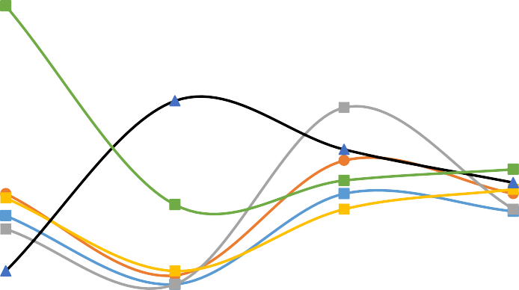

**Figure 4.4: Total Bacteria Count for 4 weeks**

700

600

500

400

300

200

100

0

0

1

2

3

4

5

No. of Weeks

Sample 1

Sample 2

Sample 3

Sample 4

Sample 5

Sample 6

Total Bacteria Count

|  |  |  |  |  |  |
| --- | --- | --- | --- | --- | --- |
| Sampling Container | Weight of crushed  camphor (grams, g) | Salmonella Shigella | Manitol salt agar | MacConkey agar | Nutrient agar |
| 1 | 7.38 | Yielded single  growth bacteria | No growth | Yielded mixed  growth bacteria | 208 |
| 2 | 14.25 | Yielded mixed  growth bacteria | No growth | Yielded mixed  growth bacteria | 240 |
| 3 | 21.91 | Yielded mixed  growth bacteria | No growth | Yielded mixed  growth bacteria | 212 |
| 4 | 29.44 | Yielded mixed  growth bacteria | No growth | Yielded mixed  growth bacteria | 248 |
| 5 | 32.20 | Yielded mixed  growth bacteria | No growth | Yielded mixed  growth bacteria | 260 |
| 6 | Control | Yielded mixed  growth bacteria | No growth | Yielded mixed  growth bacteria | 284 |

Below is a picture taken in the laboratory during Total Bacteria Count

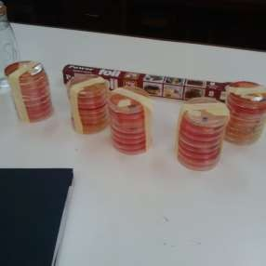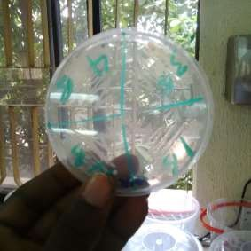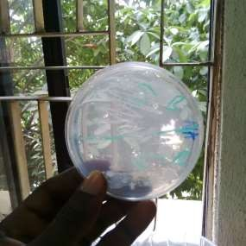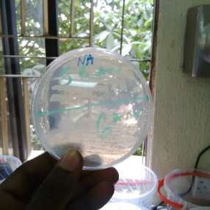

Plate 4.3: Various agars used to culture the bacteria found in the sewage sample.

# CHAPTER 5

## CONCLUSION AND RECOMMENDATIONS

## Conclusion

The effect of camphor on aerobic sewage degradation has been studied. Although, camphor which is used in reducing odor and as a repellant for pest has been used to check if it helps in increasing the microbes required for sewage degradation in the septic tank.

However, from the physio-chemical and bacteriological studies carried out on the sewage sample, it has showed that during the first week of analysis, the pH of the sewage was ideal and helped in bacteria growth but from the second to fourth week, the pH level of the sewage sample was alkaline as showed in Table 4.1 to 4.8. At high temperatures, there is an increase in the biological activity in the sewage sample. From Fig. 4.1, which shows the bacteria removal efficiency at 14, 21 and 28 days, it is observed that camphor helped to improve the strength of the bacteria as there is an increase in the bacteria removal efficiency. In Fig. 4.2, the total dissolve solids (TDS) removal efficiency was observed to be in the increase for 14 and 21 days which shows that the bacteria is active and is performing its function in degrading the organic matter present in the sewage sample. From Fig. 4.2, which shows the reduction of TDS at 28 days which can be considered as the bacteria being inactive due to less organic matter. The values gotten for the total suspended solids (TSS) as showed in Fig. 4.3 for 21 days was high due to the fact that the sewage sample was turbid and contained lots of suspended particles. But this reduced in day 28 which depicts the bacteria reducing the suspended particles in other to ensure clarity.

Furthermore, this study has been able to show that different bacteria and micro-organisms are contained in sewage in which camphor helps these bacteria to effectively carry out degradation of organic matter present in sewage. Although in the long term, camphor reduces the ability of these microbes thereby making them inactive which leads to less organic matter being degraded and increase in shock loading or hydraulic failure in the septic tank system.

## Recommendations

The following recommendations are suggested due to the outcome of the experiment.

* + 1. During the application of camphor to the toilets in homes and eateries, little amount should be used.
    2. Appropriate awareness programs should be created to enlighten people on the use of camphor and its effect on septic tank.
    3. Manufacturers are advised to put the health of the septic tank system into consideration while producing these chemicals by producing chemicals with little or no interference to sewage degradation.
    4. Proper water analysis test should be carried out for wells and boreholes close to septic tanks in other to ensure that there is no groundwater contamination.
    5. Adequate measures should be put in place to take care of failures that may occur in septic tanks.
    6. For eateries, with high rates of customers, a 2 to 3 weeks desludging of the septic tank is necessary in other to avoid septic tank failure.

# References

1. Agunwamba, J. C. (2000). *Water Engineering and Management Tools*. Enugu, Enugu: Immaculate Publications.
2. Agunwamba, J. C., Tenebe, I. T., & Emenike, P. C. (2013). *Effect of disinfectants on aerobic sewage degradation using Dettol and Izal as case study*. Retrieved March 28, 2016, from

[https://www.researchgate.net/publication/260244147_EFFECT_OF_DISINFECTANTS_](https://www.researchgate.net/publication/260244147_EFFECT_OF_DISINFECTANTS_ON_AEROBIC_SEWAGE_DEGRADATION_USING_DETTOL_AND_IZAL_AS_CASE_STUDY) [ON_AEROBIC_SEWAGE_DEGRADATION_USING_DETTOL_AND_IZAL_AS_CA](https://www.researchgate.net/publication/260244147_EFFECT_OF_DISINFECTANTS_ON_AEROBIC_SEWAGE_DEGRADATION_USING_DETTOL_AND_IZAL_AS_CASE_STUDY) [SE_STUDY](https://www.researchgate.net/publication/260244147_EFFECT_OF_DISINFECTANTS_ON_AEROBIC_SEWAGE_DEGRADATION_USING_DETTOL_AND_IZAL_AS_CASE_STUDY)

1. AWWA Home. (1999). Retrieved March 28, 2016, from <http://www.awwa.org/>
2. Budavari, S. (1989). Retrieved March 28, 2016, from <http://www.oalib.com/references/9356515>
3. Consortium of Institutes for Decentralized Wastewater Treatment (CIDWT), 2009. Retrieved March 28, 2016, from <http://onsiteconsortium.org/>
4. Delaware Department of Health and Social Services (DHSS). (2009). Retrieved March 28, 2016, from <http://www.dhss.delaware.gov/dhss/>
5. Department of Health. (n.d.). Retrieved March 31, 2016, f[rom http://www.health.ny.gov/](http://www.health.ny.gov/)
6. *Design Manual: Onsite wastewater treatment and disposal systems.* (1980). Washington DC: U.S.E.P.A. Office of Technology Transfer.
7. Dhall, P., Kumar, R., & Kumar, A. (2012). *Biodegradation of Sewage Wastewater Using Autochthonous Bacteria.* The Scientific World Journal, 2012, 1-8.
8. Ela, W. P. (2007). *Introduction to environmental engineering and science* (3rd ed.). Prentice Hall.
9. Eweka, A., Adjene, J., & Enaibe, B. (2009). *Histological Studies Of The Teratogenic Effects Of Camphor On The Developing Kidney Of The Wistar Rats. Annals of Biomedical Sciences, 7*(1-2).
10. Gray, N. F. (1989*). Biology of wastewater treatment.* Retrieved from [www.sci.u- szeged.hu/ABS](http://www.sci.u-szeged.hu/ABS)
11. Harder, J., & Fob, S. (1999). *Anaerobic Formation of the Aromatic Hydrocarbon p- Cymene ...* Retrieved March 28, 2016, from [http://www.dzumenvis.nic.in/Biodegradation/pdf/Anaerobic formation.pdf](http://www.dzumenvis.nic.in/Biodegradation/pdf/Anaerobic%20formation.pdf)
12. Hoover, M. T., Disy, T. M., Pfeiffer, M. A., Dudely, N., Mayer, R. B., & Buffington, B. (1996). *North Carolina subsurface system operations training school manual.* Raleigh, NC.
13. *INDG197 - Working with sewage: The health hazards.* (1995). Retrieved March 31, 2016, from <http://www.hse.gov.uk/pubns/indg197.pdf>
14. *IUCLID CD ROM - International Uniform Chemical Information Database: Extract of data from the international uniform chemical information database on high production volume chemicals (HPVCs)*. (2000). Ispra.
15. Jiang, J., Zhao, Q., Wei, L., Wang, K., & Lee, D. (2011). *Degradation and characteristic changes of organic matter in sewage sludge using microbial fuel cell with ultrasound pretreatment. Bioresource Technology, 102*(1), 272-277.
16. Li, S. (2011). *Enhancement of the antimicrobial activity of Eugenol and Carvacol against Escherichia coli 0157:H7 by lecithin in microbiological media and food.* Retrieved March 28, 2016, from <http://trace.tennessee.edu/utk_gradthes/996/>
17. Minnesota Rules Chapters 7080 through 7083 Subsurface ... (n.d.). Retrieved March 28, 2016, from

<http://www.septic.umn.edu/sites/septic.umn.edu/files/minnesota_rules_chapter_7080.pdf>

1. North Dakota Department of Health. (n.d.). Retrieved March 30, 2016, from [www.ndhealth.gov](http://www.ndhealth.gov/)
2. National Research Council, 1994. Retrieved March 28, 2016, from <http://www.nrc.gov/>
3. OECD Guidelines for the testing of Chemicals. (1998). France, Paris: OECD
4. PRELIMINARY TREATMENT - Environmental Protection Agency ... (1997). Retrieved March 28, 2016, from [http://www.epa.ie/pubs/advice/water/wastewater/EPA_water_treatment_manual_prelimin ary.pdf](http://www.epa.ie/pubs/advice/water/wastewater/EPA_water_treatment_manual_preliminary.pdf)
5. *Public review draft*. (2010). Reston, VA: U.S. Dept. of the Interior, U.S. Geological Survey.
6. Reynold, J. E. (1989). *Martindale - The Extra Pharmacopoeia* (29th ed.). London: Pharmaceutical Press.
7. Saha, A., Haque, M., Karmaker, S., & Mohanta, M. (2009). *Antibacterial effects of some antiseptics and disinfectants.* (Vol. 3-4). Raj Shashi, Bangladesh. doi:10.3329/jles.v3i0.7440
8. Siuris, A. (2011). *Properties of sewage sludge resulted from urban wastewater treatment in the Republic of Moldova* (Vol. LIV, A). UASVM, Bucharest: Scientific Papers.
9. *Standard analytical procedures for water analysis.* (1999). Technical Assistance, Hydrology Project
10. Vreugdenhil, D., Terborgh, J., Cleef, A. M., Sinitsyn, M., Boere, G. D., Archaga, V. L., & Prins, H. H. (2003). *Comprehensive protected areas system composition and monitoring*. Shepherdstown, WV: WICE.
11. Wiechmann, B., DieneMann, C., Kabbe, C., Brandt, S., Vogel, I., & Roskosch, A. (2013). *Sewage sludge management in Germany* - Umweltbundesamt. Retrieved March 31, 2016, from [https://www.umweltbundesamt.de/sites/default/files/medien/378/publikationen/sewage_sl udge_management_in_germany.pdf](https://www.umweltbundesamt.de/sites/default/files/medien/378/publikationen/sewage_sludge_management_in_germany.pdf)